C | U | R | R | I | C | U | L | U | M
 |  |  |  | V | I | T | A | E
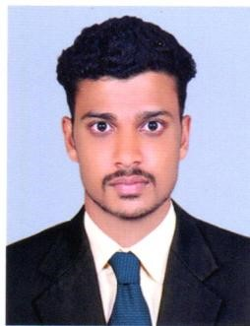Name : RIYAS

E-mail: riyas-395974@gulfjobseeker.com

Objective: To join a professional establishment for challenging opportunities where my experience are honed and are best utilized for the betterment of organization and also my career. The premier objective will be always performing my duty with efficiency, practical experiences and guidance of organizational system.

PROFILE
•

•

•

•

Completed B-Com from Calicut University

CAPABILITIES
Good communication and interpersonal skills.
Meticulous and hard working.
Displaying initiative and independence and can work on own or as a part of a team.

EDUCATION
B-com ( Calicut University)
Plus two (Board Higher Secondary Kerala)
SSLC (Central Board)

WORK EXPERIENCE
2 Years experience as a SALES in a Supermarket/ Grocery store in Dubai, UAE
- customer attending proficient in achieving optimal customer experience through Excellent interpersonal and great attitude
- Product Display
- Ordered and managed stock and stocked shelves
- Served and assisted customers on checkouts
- Answered phone and helped with queries and complaints remaining professional at all times

3 Year Experience as a SALES EXECUTIVE in SAMIYA SILKS ,
KERALA , INDIA

- Meeting and greeting customers and making them feel welcome •Stock arranging well versed in performing daily store maintenance taks•Supervising junior sales representatives.
- Ensuring sales target are met before the specified deadlines
- Able to quickly build a report to the customer

COMPUTER SKILLS

MS office
ERP

PASSPORT DETAILES

Visa Status : Visit Visa
Joining Status : Immediate

LANGUAGES KNOW
To Speak : English , Arabic , Hindi and Malayalam.
To Read and Write : English , Arabic , Hindi and Malayalam
PERSONAL DETAILS
Date of Birth | : | 13/12/1993
Nationality | : | Indian
Religion | : | Islam
Gender | : | Male
Marital Status | : | Single
SKILLS:

Communication.
Ability to Work under Pressure.
Decision Making.
Time Management.
Self-motivation.
Conflict Resolution.
Leadership.
Adaptability

DECLARATION
I sincerely believe that the above mentioned facts are true to my knowledge and belief.

Place: Dubai Yours Truly

Date: Riyas

