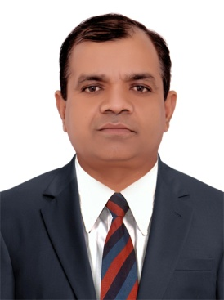
CURRICULUM VITAE

VIJAI
- E-Mail: vijai-396121@2freemail.com

Dubai, U.A.E

POST APPLIED FOR:Civil SUPERVISOR
OBJECTIVE

To seeking a challenging career by copying a suitable position, utilizing my technical skills and experience to contribute towards the progress of organization at the same time has the prospect for professional growth and development my career.

WORK EXPERIENCE

- Presently working as a General Foreman in General Contracting Company in Dubai since 07/11/2017 till date.

- Worked as a General Foreman in General Contracting Company in Dubai from07/07/2014 to 23/07/2017.

- Worked as a General Foreman in General Contracting Company in Dubai from 05/01/2010 to 31/12/2013 New yark University Abu Dhabi Project (Masonary & Interior, Painting, ceiling, Tiles and Plaster.

- As a Sub Contractor in Dosal Pvt. Ltd Jumairah village 3rd Project from 23/06/2007 to 19/12/2009.

- Worked as a Foreman in Dubai from 09/02/2000 to 08/02/2006 work masonary and inferior.

- Worked as a Jr.Foreman in Oman From 05/03/1997 to 04/03/1999 work masanory and inferior.

PROJECT PROFILE

- Cement Factory Salalah, Oman
- Labour camp al Qouz Dubai
- Builing project G+5, Dubai
- Emirates Hotel G+22 Dibba Fujairah
- Ware house Jabel Ali & Al qouz
- Commercial Villas & Residential Villas

EXPERIENCE IN INDIA

- Worked as an Assistant Foreman in Baldev Palaza Gorakhpur, U.P from 06/08/1995 to 05/03/1996.
- Worked as a Foreman in Bil Moria Co.Bombay from 06/041996 to 12/01/1997.

KEY EXPERIENCE

All working Finishing and Ineriors

PERSONAL PROFILES

Date of Birth : 10/10/1974
Nationality : India
Gender : Male
Marital Status : Married
Languages Known : Hindi, English

EDUCATIONAL QUALIFICATION

- 10th U.P Board 1990
- 10+2 U.P Board 1192
- B.A Gorakhpur Unversity Gorakhpur (U.P)

PASSPORT DETAILS:

- Date of Issue : 13/04/2015
- Date of Expiry : 12/04/2025
- Visa Status : Employment visa

SAFETY

- I am well conversant with the safety rules and regulation.
- Always obey ABC point like, always be careful, dont wear loose clothes in the
Working hour, and don't work in tension, always think of safety & work safety

CONCLUSION & DECLARATION:

I hereby certify that the above mentioned Statements are correct & true to the best of my belief & knowledge.

Dubai VIJAI

