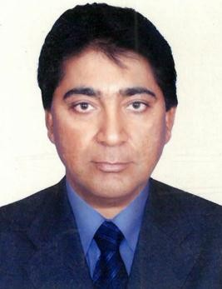
CURRICULUM VITAE

PARBHAT
DUBAI-UAE
Email: parbhat-396137@2freemail.com

POST APPLIED FOR: MARINE FLOATING CRANE OPERATOR
OBJECTIVE:
To seeking a challenging career by copying a suitable position, utilizing my skills and experience to contribute towards the progress of organization at the same time has the prospect for professional growth and development my career.

EDUCATIONQUALIFICATION:
- 10th class

WORKING EXPERIENCE
Total Working experience – 25 years Working in UAE – 15 Years
✰ Since 23/01/2005 to till date working as a Marine Floating Crane Operator
Working Crane Models - LIMA, AMERICAN, MANITOWOC , KABLCO ,ATC
✰ 08 years working experience
  - Worked in Saudi Arabia for 05 years and Cyprus for 03 years
✰ 02 years working experience in Malaysia
LICENSE DETAILS:
- Date of Issue : 22/10/2005
- Date of EXPIRY : 21/10/2025
- Place of Issue : Sharjah
- Vehicle Status : Heavy Tractor (8)
- Having floating crawler crane operator certificate holder from CLAYMORE

PERSONAL PROFILES:
- Name : Parbhat
- Religion : Hindu
- Date of Birth : 26/01/1970
- Nationality : Indian
- Marital Status : Married
- Languages Known : English, Hindi and Punjabi

PASSPORT DETAILS:
- Date of Issue : 06/09/2011
- Date of EXPIRY : 05/09/2021
- Visa Status : Employment Visa

CONCLUSION & DECLARATION:
I hereby declare that the above mentioned Statement is correct & true to the best of my knowledge & belief.

PARBHAT

