CURRICULUM VITAE

SUMESH

Email: sumesh-396177@2freemail.com

DUBAI-UAE

POST APPLIED FOR
CAMP BOSS JOB

PERSONAL DATA

Date of Birth : 24-01-1989 Sex : Male
Religion : Hindu
Nationality : Indian Marital Status : married
Languages : English, Hindi,
Tamil, Malayalam
Hobbies : Reading, cricket, music, Internet

OBJECTIVE

Seeking an increasingly responsible position in your organization ,career development and challenging environment where my qualification, experience and dedication can be utilize for the prospect of the organization.

EDUCATIONAL & TECHNICAL QUALIFICATION

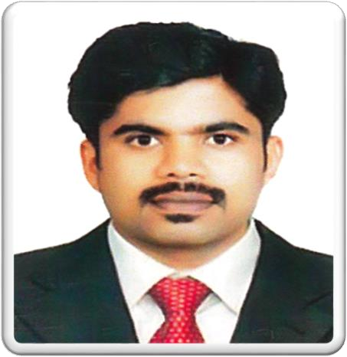
LICENSE DETAILS

Date of Issue : 13-02-2018 Date of Expiry : 13-02-2020 Place of Issue : DUBAI
Category : Automatic Gear
Light Vehicle (3)

PASSPORT DETAILS

Date of Issue : 30-04-2012 Date of Expiry : 29-04-2022

Diploma in Mechanical Engineering
Higher secondary ( Kerala Examination Board)
SSLC ( Kerala Examination Board)

OTHER ACHIEVEMENTS

- IOSH (Institution of Occupational Safety And Health) Certificate.
- Fire Fighting (Fire Fighting Training Center, Cochin Ship yard Ltd.Kochi)
- First Aid (India Red Cross Society Kerala State Branch)
- DPS ( Licensed Department Protective System- Dubai Police Academy Dec 2015)

SIRA Card Holder

CURRICULUM VITAE

COMPUTER KNOWLEDGE
- Diploma in computer application ( Word , Excel etc )
- Basic Networking Training, Electronic Security and Surveillances

WORK EXPERIANCE
- 3 years experience as a SAFETY OFFICER in INDIA from 15th may 2010 to 30th june 2013
- 2 years experience as a SAFETY OFFICER INDIA from 10th july 2013 to 30th septemper 2015.
- 4 years as a CAMB BOSS in –DUBAI
-UAE since 24th October 2015 to 24th December 2019

JOB PROFILE
- Manage labor accommodation which involves cleaning, maintenance occupancy in the camp, safety & security.
- Inspects all camp facilities and reports to relevant personnel.
- Supervises and orients camp Laborers.
- Maintain first aid supplies.
- Ensure discipline in the camp and to follow company/camp policies
- Report workers staying in the camp/not reporting to duty on a daily basis to the Management along with the valid reason on each case.
- Daily camp checking, total staff details, daily reports & monthly reports sent to the Management and HR Department. Report accident/incident of any staffs to PRO and HR Department for necessary immediate action
- Responsible for the effective cleaning of the camp and all its corresponding areas, the dining, washrooms, kitchen etc.
i. 24*7 be ready for emergency treatment of workers

CONCLUSION AND DECLARATION
I Here by that the above Information are true and Correct According to the Best of My Knowledge and Believe.

SUMESH

