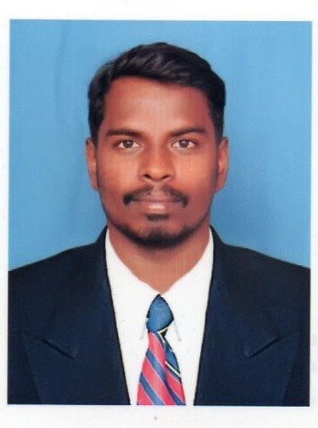 |  | JEEVA  Civil Engineer
OBJECTIVE  To prove my skills in the field according to your requirement and give my utmost service to the company in a flexible way to achieve my goals.  Contact  EMAIL:  Jeeva-396193@2freemail.com  Hobbies  Listening to Music  Dancing  Cycling  Internet surfing  REFERENCEs  Will provide on request |  | EDUCATION  Bachelor of Civil Engineering - Anna University, Ranipettai Engineering College (2013 – 2017)  Higher Secondary - Islamiah Boys Higher Secondary School, State Board of Tamil Nadu (2011 – 2013)  WORK EXPERIENCE  Chennai, India – Junior Designer Engineer  05-aug-2017 to 25-Sep-2018  Key Roles:Design Engineer, Maintained Project Planning and Billing  Diamond Infra Construction Pvt LtdMylapore, Chennai India – Site Engineer  Dec-2018 to Apr-2019  Key Roles:Site Engineer and maintained project Planning and billing  TECHINICAL QUALIFICATION  Well versed in using PCs & Laptops  Excellent knowledge in MS Office  Certified in Courses like Drafting Tools  : AutoCAD 2D & 3D  : Google SKETCHUP  : STAAD PRO  : REVIT  : Management in PRIMAVERA P6

CERTIFICATIONS & TRAINING
- Graduate Engineer Trainee from Diamond Infra Construction Pvt Ltd, Chennai, Tamil Nadu, India - 2018

- Participated “Tall Building Design Workshop”, VIT Vellore, Tamil Nadu, India - 2017

- Vocational In plant Training from 12 to 17 Aug. 2016 in Work of “ Construction of 64 HIG Residential Flats With Development Works ” Vellore, Tamil Nadu, India - 2016

project completed
- AN EXPERIMENTAL INVESTIGATION OF COCONUT SHELL IN CONCRETE

ABSTRACT: The cost of traditional materials used in the concrete is the major factor which is increasing cost of constructions, so it is necessary to research for alternative construction materials. This coconut shell used as a light weight aggregate in concrete, the properties of coconut shell concrete examined.

AREA OF INTEREST
- Design Engineer
- Site Engineer
- billing
- Planning and Survey

PERSONAL PROFILE

Date of Birth : 26-July-1996
Nationality : Indian
Visa Status : Visit Visa, expire on 17-Mar-2020
Marital Status : Single
Languages Known : English, Urdu & Tamil

DECLARATION
I hereby declare that the above furnished information are true to the best of my knowledge and belief and I assure that I will be an inclining aspect to your esteemed organization.

Yours Truly,

JEEVA

