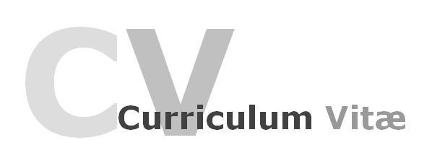
RAMSON
Address : Dubai, U.A.E
Email : ramson-396356@2freemail.com
Date of Birth : 01/07/1995
Nationality : Cameroonian
Gender : Male
Marital status : Single
Languages known : English and French.
Visa Status :Working

High-energy warehouse assistant focused on promoting customer satisfaction through exceptional service and maintaining outstanding warehouse performance. Organized diligent and skilled in handling multiple tasks and repair projects at the same time. Expert knowledge in warehouse products and techniques. Focuses on completing all tasks quickly and with high quality standards in mind. Accommodates customer needs at all times.

- WAREHOUS ASSISTANCE QC IN BUND & OUT BOUND: DUBAI ONE YEAR SERVICE.
- WAREHOUSE INVOICER DUBAI. SIX MONTHS EXPERIENCE
- WAREHOUSE ASSISTANT 6 MONTHS EXPERIENCE
- STOREKEEPER SERVICE: DUBAI LOGISTIC TEAM 6 MONTHS SERVICE.
- SALES MAN: BUILDING MATERIAL in CAMEROON 2012-2015
- BUILDING,FINISHING AND QUANTITATIVE ENGINEER: MY OCCUPATION.

DUTIES & RESPONSIBILITIES: WAREHOUSE ASSISTANT
- Receiving, moving, checking and storing incoming goods.
- Checking and inspecting goods received and ensuring they are of accurate quantity, type, and also acceptable quality.
- Packaging and labeling products before they are dispatched.
- Helping to ship out over 500 lines every day.
- Picking and packing products.
- Selecting space for storage and arranging for good to be placed in the designated areas.
- Making sure that all inventory processes are completed on the same day.
- Loading and unloading lorries, vans and other vehicles.
- Preparing deliveries for the van drivers.
- Supervising the work of junior staff.
- Ensuring a clean and safe workhouse for staff to work in.
- Storing stock away safely.
- Removing hazardous products from the warehouse.
- Signing off and replenishing stock.
- Monitoring stock levels.
- Moving items through the warehouse from receipt to dispatch to customers.
- Occasionally delivering stock to shops and retail outlets.
- Accurately updating all data into computer and manual recording systems.

- Excellent ability to plan, organize and prioritize my work in a team environment.
- Work well under pressure.
- Reliable employee that value hard work, integrity and patience.
- A good and productive employee, dependable and self-motivated.
- Project Management
- Communication Skills
- Creativity and formations skills.
- Basic knowledge in online sales
- Good in MS word
- Critical Thinking
- Fluent in speaking and writing of English language
- Excellent in calculations quantities and quantitative estimate of a given project.
- Excellent in reading and interpreting English Language.

CAP/O Level certificate
BACC/A Level certificate

I do certify that the above information furnished by me in this curriculum vitae is
true and accurate.

