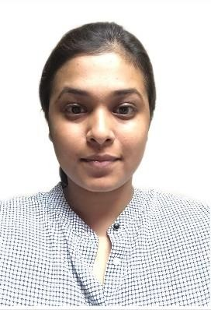

Ruchi

Date of birth : 19th August 1996 Email : ruche-396391@2freemail.com
Visa Status : Visit Visa (3 Months)
Passport Detail : (Issue Dt- 09th March 2019
Expiry Dt -08th March 2028)

Personal Profile
My goal is to become associated with a company where I can utilize my skills and gain further experience while enhancing the company’s productivity and reputation.

Skills
Technical Skills
- Tally ERP.09
- MS Office, MS Excel, MS. Word

Personal Skills
- Service Oriented.
- Punctual and Hard Working.
- Time Management Skills

Qualification and Certificates
- Graduated from Mumbai University , India with commerce in the year 2017.
- 12th from Mumbai University, India with commerce in the year 2014.
- 10th from Maharashtra State Board in the year 2012

Work Experience
Assistant Account
In Steel Manufacturing / Proprietorship
Mumbai, India
May 2018 to November 2019

Customer Service Executive
In a BPO company
Mumbai, India
April 2017 to Oct 2017

Hobbies and Interests
Cooking, Travel, to listen Soft Music, Dancing, and to interact with different people. Enhancing myself with latest news and tech

Reference
Excellent references will be provided upon request.

Ruchi

