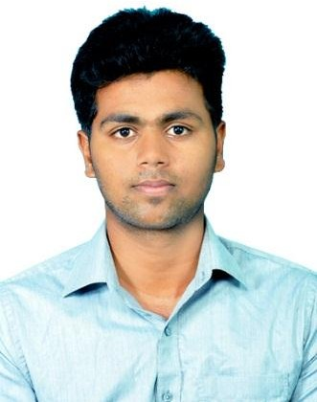
Jawahar
Mechanical Engineer

jawahar-396509@2freemail.com
Dubai, United Arab Emirates

Visa Type: Tourist Long Term (Till Feb 27, 2020)

Nationality: Indian

A Meticulous and Prudent Professional with Mechanical Engineering Background; having One-year Indian experience in Networking in Telecom Industry

IT Skill Sets

General Software | Mechanical | Networking
Microsoft Office Java  HTML and CSS Adobe Photoshop  Acrobat PDF | SOLID WORKS  Auto CAD Creo | AZENQOS  Speed Testing

Professional Experience
Telecom/ Networking Industry in India as Associate Engineer (Mar. 2018 – Feb. 2019)

Key Responsibilities:
- Responsible for taking survey on technical data for all relative telecom technologies 2G, 3G and 4 G using Software - AZENQOS
- Installing the routers and repeaters for boosting purposes for companies and living area, managing the performance of the same
- Testing like – LTE, WDCM, GSM - Signal Range & Frequency Testing, Drive Testing, Mobility Handover Testing have been regularly checking and updating the same
- Responsible for generating reports by implementation and driving the overall technical installation and maintaining and reporting to the management and planning team
- Attending the customer complaints, quality issues like frequency problems, data speed and coverage problems and resolving it
- Expert in reporting office administration software like MS Word, Excel and PPT. Generating regular reports in Excel and Presentation in PPT and submitted to Team Management

Educational Qualification

Academic Qualification
- Bachelor of Engineering in Mechanical from SVS College of Engineering, Anna University in 2016 – 71.5 % (CGPA – 7.1)

- Higher Secondary – Matric – from Bharathi Matric. Higher Secondary School in 2012 - 85.5 %

- Secondary School (SSLC) – Matric – from Bharathi Matric. Higher Secondary School in 2010 - 81 %

Professional Certifications
- Certified in Solid Modelling using creo 2.0 From DMW CNC Centre Certificate No: 0214CAD19

Projects Accomplishments

Mechanical Dishwasher - Manufacturing Technology
- Dishwashing having two types like automatic and manual dishwashers. We are improving the dishwashing type like mechanical oriented type by using man power, mainly our Target's for physically challenged people's. The dishwasher Made up of some mechanical instruments like gears, pulley and belts and some stuffs .it will be low expensive and portable .and it will be easy handling
- Project role: Team Leader
- Software used: Creo
Paper Conserving Machine - Design of Transmission System
- Stop and Go Gear Mechanism (In this project we will be taking on a paper winding machine. Normally this machine has cutting a 500 papers per minute but we are increasing the cutting speed by 1000 papers per minute. By using the stop and go gear mechanism with help of gears and pulleys. Our Target's in this project is to increasing the production value and low consumption /Timing.)
- Project role: Team Leader
- Software used: Creo

Personal Information
Date of Birth: 30/10/1995
Nationality: Indian
Place: Tamilnadu, India
Marital Status: Single
Known Languages: English, Tamil, Malayalam

I hereby declare that all the details furnished here are true to the best of my knowledge.

(Jawahar)

