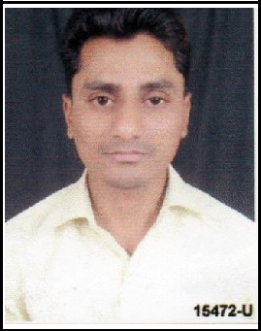
CURRICULUMVITAE

JAMSHED

Email: jamshed-396703@gulfjobseeker.com

Objective:
Toutilizemytechnicalskilsforachievingthetargetanddevelopingthebest

performanceintheorganization.Iwouldliketoimplementmyinnovativeidea,skils

andcreativityforaccomplishing

theprojects.

Experience:
TotalWorkExperience:4years

GULFEXPRIENCE:FromMay2019totildate

Designation: CivilEngineer

Project: DewaPhaseIII800MWPVSolarPowerProject.

Client: DEWA

MainContractor:GRS,ACCIONA,GHELLA(EPC)

Location: MohammedBinRashidALMaktoumSolarPark,AlQUDRADubai.

INDIANEXPERIENCE:

Experience: 1year

Duration: October2017toDec2018

Designation: CivilSiteEngineer

Company: SparklingSunRealEstateIndorePvt.Ltd.

Project: RelianceJio4GTower(Telecom)

Client:. RelianceIndustriesLtd.

Experience: 2years

Duration: August2015toSeptember2017

Designation: SeniorCivilSiteEngineer

Company: AmbrosiaBuildconPvt.Ltd.

Project: ResidentialBuilding(G+5)

Roles&Responsibility:

Goodco-ordinationwithclient&

sub-contractor

Projectplanning

Billingofsub-contractors

SiteInspection&reporting

PrepareofBOQ

ProfessionalQualification:
DiplomaincivilengineeringfromIntegralUniversityLucknow(2015)

B.comfromShiaP.GColegeLucknow(2011)

AcademicQualification:
IntermediatefromU.Pboard(2008)

HighschoolfromU.Pboard(2005)

ExtraQualification:
AdvancediplomaincomputerapplicationfromVinayaktechnicalinstituteLucknow.

PersonalSkil:

Smartworking.

Quicklearner.
PassportDetails:

DateofIssue: | 22/09/2015
DateofExpiry: | 21/09/2025
Visastatus: | Residentvisa(Transferable)
PersonalDetails:
Maritalstatus: | Unmarried
Language: | English,Urdu,Hindi
Dateofbirth: | 12/04/1988

Date:

Place:Dubai (JAMSHED)

