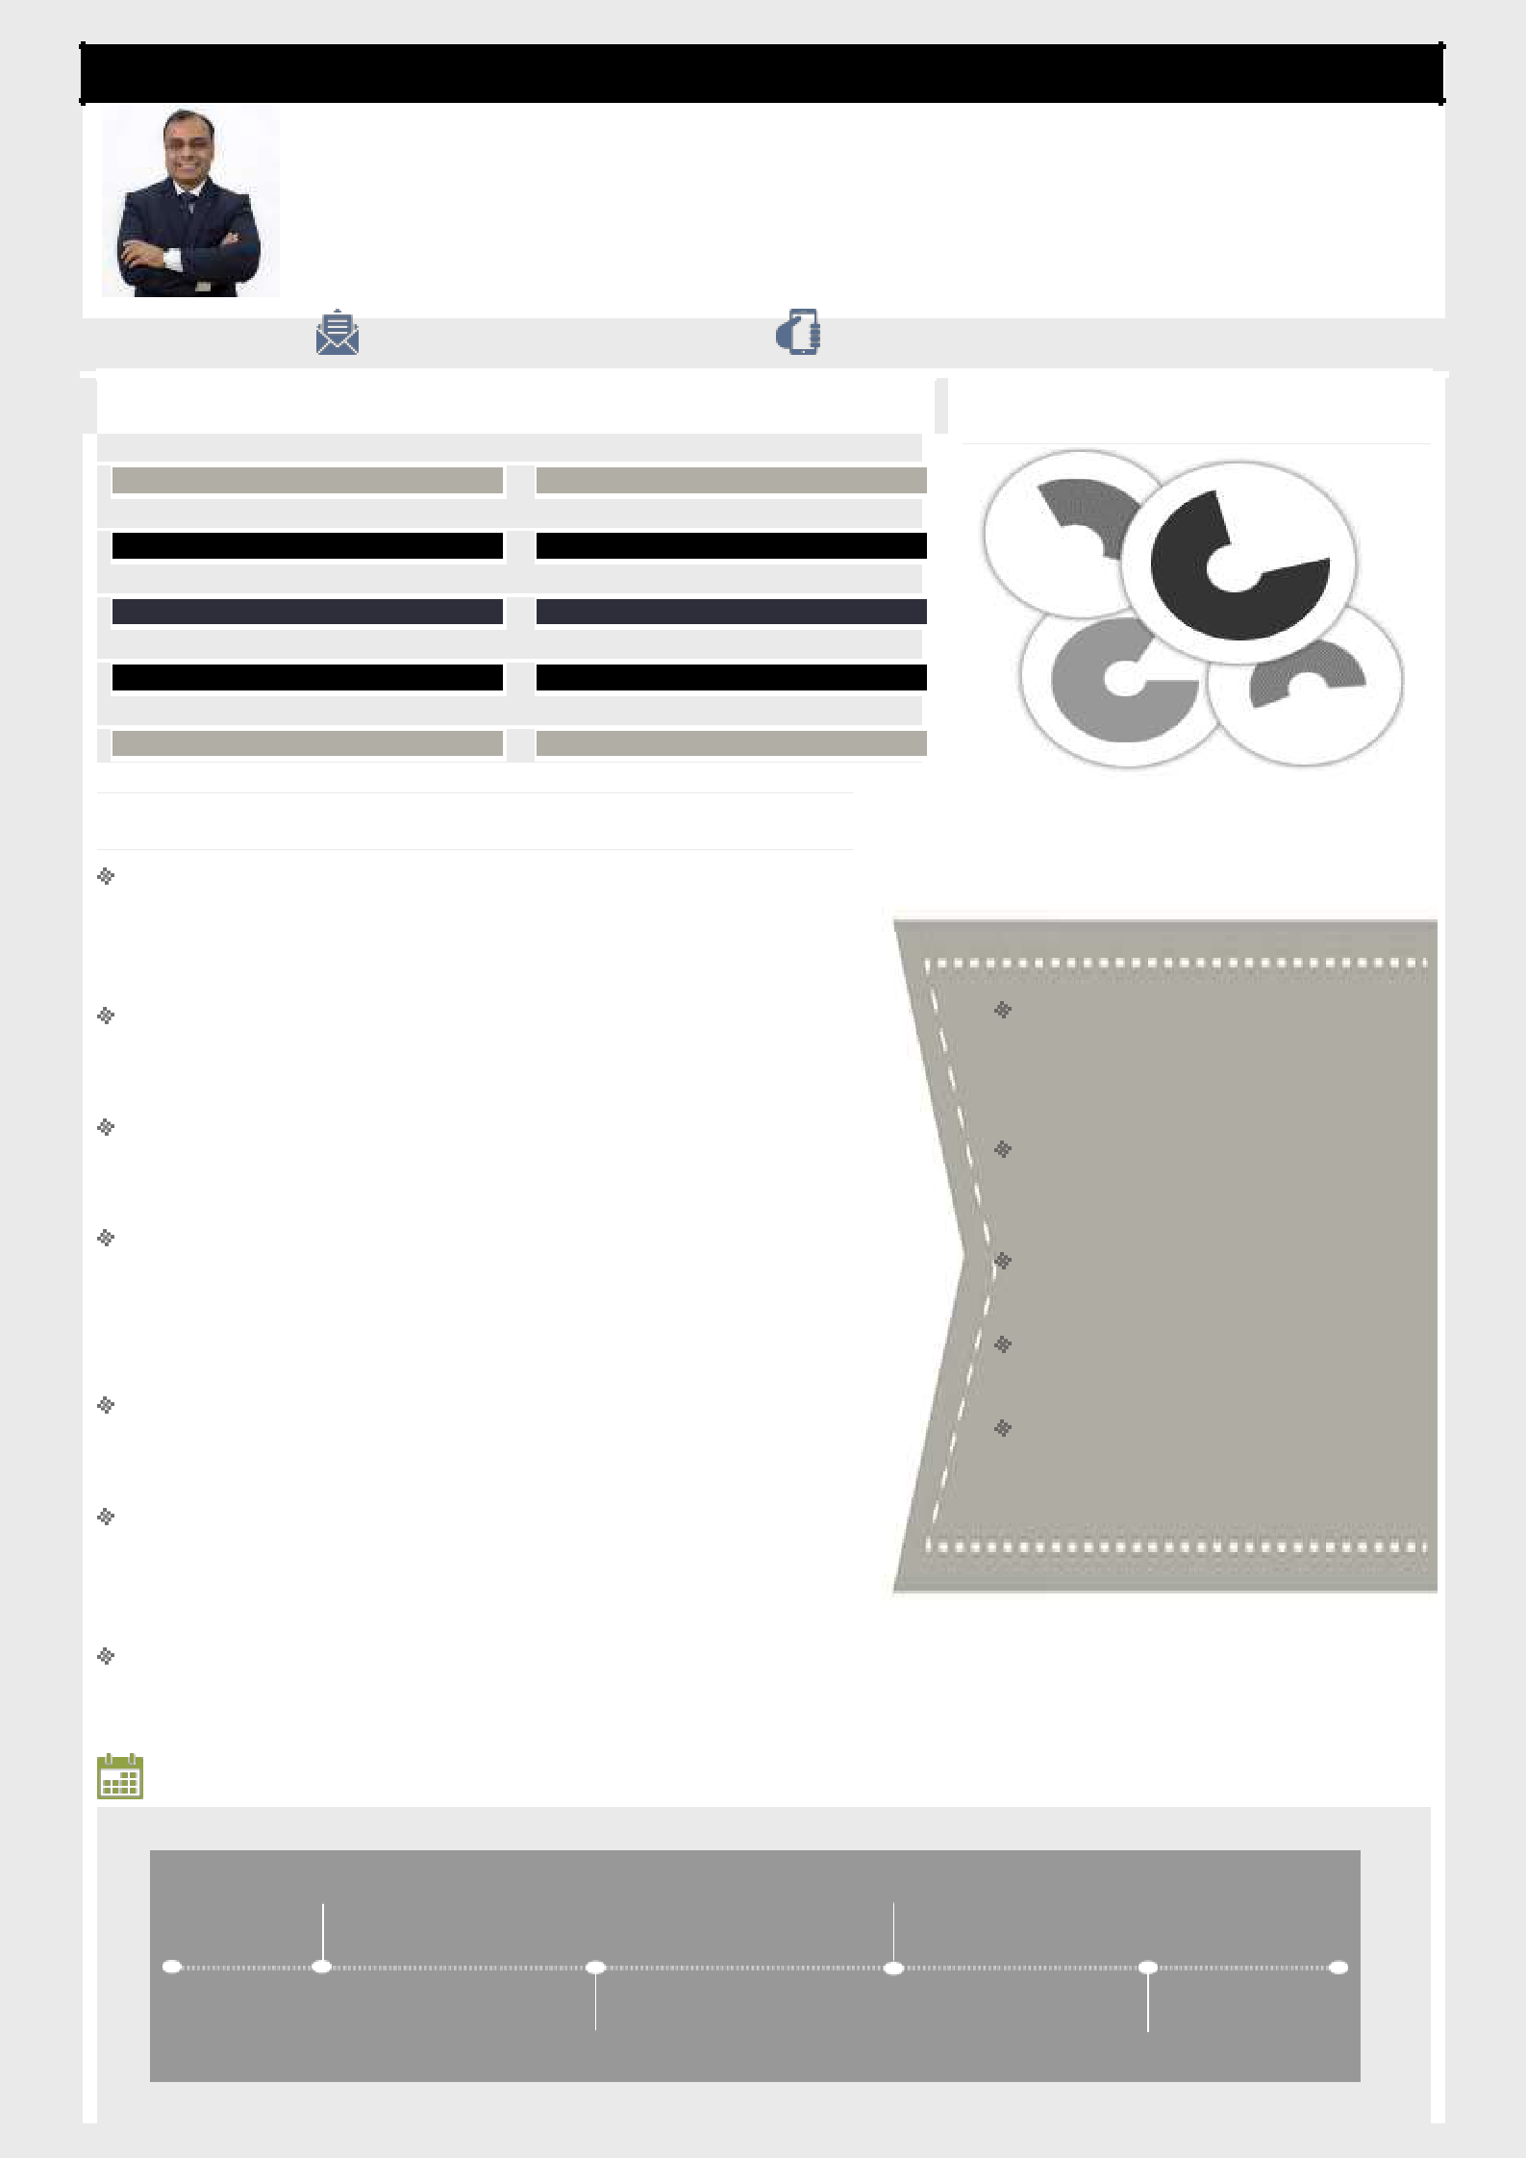
Arnav

Proven career in conceiving & implementing effective ideas / strategies that can add value to organization through inspiring leadership, rich experience & innovation excellence; targeting challenging assignments in
Sales/Business Development/Channel & Distribution Management

Arnav-396710@gulfjobseeker.com

Core Competencies

Strategic Business Planning | Revenue & Pipeline Growth

Soft Skills

Profit Centre Operations | Distribution & Retail Networks |  | Learner
 |  | Strategist
New Store Planning & Roll-out | Go-to-Market Strategy
Product Launches & Promotion | Customer Lifecycle Management
Channel Expansion & Sustainability | Team Building & Leadership | Focussed | Achiever

Profile Summary

Strategic Leader offering over 16 years of combined multi-disciplinary experience of impacting organization profitability through effective strategic & tactical management decisions and new business development in Telecom & FMCG industry

In-depth understanding of diverse markets across India as well as different models of business & structures of distribution (Distributors, DSA, DST & Organized Retail)

Proven capabilities in expanding channel business by sourcing new partners and maintaining effective business relationships with existing partners to enhance profitability of business operations

Consistently delivered exceptional performance & acknowledged with multiple awards/appreciations such as Sales Head Trophy & Star of the Month in Vodafone Idea Ltd., Maestro Award in Tata Teleservices Ltd., Eklavya Award in Eveready Industries India Ltd.

Achievement-driven professional with outstanding success in managing Sales & Distribution Business controlling overall EBITDA / P&L & consistently improving top-& bottom-line performance

Exhibited excellence in the execution of multiple Global Immersion Projects; gained expertise in SPIN Selling Skills, a unique selling technique founded by Mr. Neil Rackham, founder of Huthwaite research group

Proactive member of Global Learning Committee, for steering global learning activities in campus for all the three terms in S P Jain School of Global Management

Timeline

Education

Global Master of Business

Administration (Consulting Management) from S P Jain School of Global Management (Dubai/ Sydney/ Singapore); Jan 2019 – Dec 2019
Executive Program in Business Management from Indian Institute of Management, Calcutta, India in 2010

Master of Commerce (Applied
Economics) from University of

Lucknow in 2003
Bachelor of Commerce from Lucknow Christian College, University of Lucknow in 2001

Post Graduate Diploma in Global
Sales and Marketing from NIS

School of Marketing (An NIIT

Division) in 2000

Aug'01 - Sep'05 | Nov'09 - Nov'18
Eveready Industries
India Ltd.
Mar'06 - Nov'09 | Global MBA from S
Tata Teleservices | P Jain School of
 | Global
Ltd.
 | Management

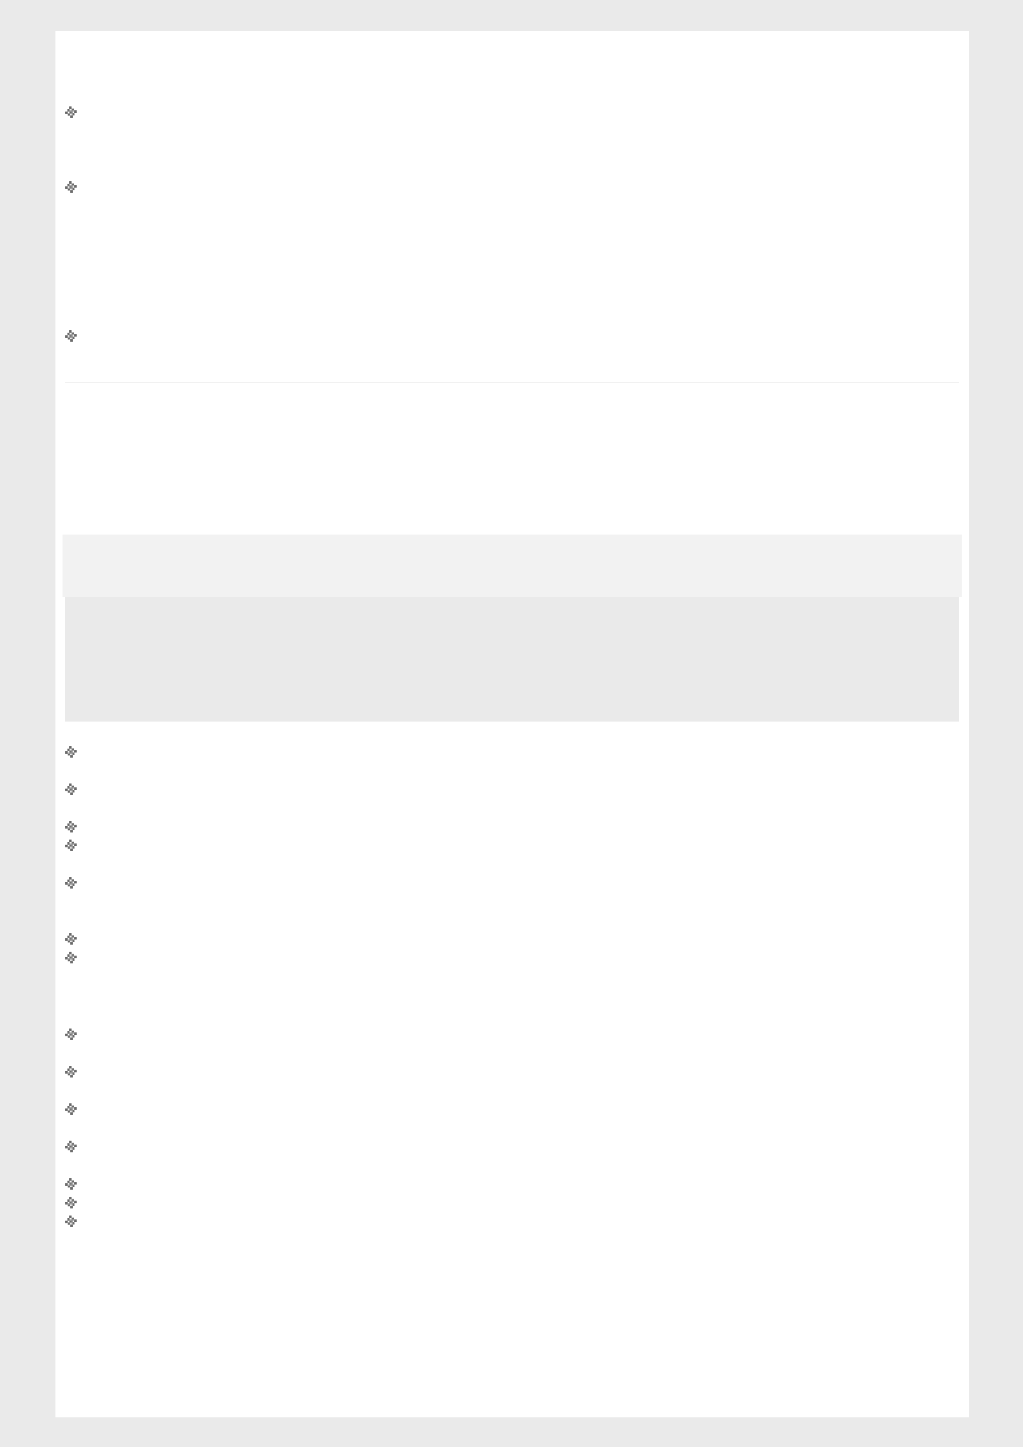
Academic Projects (SP Jain School of Global Management)
Pursuing one and completed two Global Immersion Projects:

Banking and Insurance Industry Specific Research
- Consulting company specializing in Risk, Tax, Advisory is seeking insights on Drivers, Trends & Challenges in Banking and Insurance Industry in UAE
- Secondary research- Whitepapers: Consulting companies and Annual economic report, UAE

- Boutique IT Company, wants to understand the commercial viability for the application, the target market for the app, devise low cost marketing, and pricing strategy

- Secondary research: Housing Audit report, real estate data from Australian government Primary research; In-depth interview of all the stakeholders; competitive analysis of the app

- Recommendations with pricing strategies (per lot and bundle pricing), with a break even plan considering the Scenario analysis; low cost marketing strategies and product development; judged winning team in the cohort by the client and

academic mentor

- Identifying and understanding the organization and employee resistance towards sustainability and how design thinking can play a role in mitigating the resistance

- Secondary research from McKinsey and BCG whitepapers, applied different frameworks to extract the inferences; primary research- In-depth qualitative interviews of sample industry experts across from different industries

- Recommendations with a Design thinking approach to change the perspective of Employees and Organizations towards Sustainability

Organizational Experience

Nov'09 - Nov'18

Growth Path/Deputations:

 | Nov'09 – May'11: | Territory Sales Manager (Assistant Manager) – Hardoi, India
 | Jun'11 – Dec'14: | Territory Sales Manager (Assistant Manager) – Lucknow, India
 | Jan'15 – Oct'16: | Area Sales Manager (Manager) – Basti, India
 | Nov'16 – May'17: | Area Sales Manager (Manager) – Bankura, India
 | Jun'17 – Nov'18: | Area Sales Manager (Manager) – Kharagpur, India
Key Result Areas:

Steered the KPI on revenue volumes, customer acquisition, base tower utilization, distribution of prepaid products, channel management, training and appointment of new channel partners

Lead a team comprising of direct report sales team, distributors, distributor sales team, wholesalers, supermarkets (modern trade) and different retailer formats
Managed the cross-functional product teams to achieve the business KPI

Devised programs for Channel Partners, Distributor Staff, Retailers, Employees and Associates, so as to deliver targets and have overall control on Sales & Distribution spends

Implemented measures to boost profitability through Acquisition and Revenue Market Share; spearheaded the flagship trade schemes for Vodafone Idea as well as designed short burst tactical trade offers to meet acquisition & revenue market share targets

Monitored channel partner capability and capacity management, ensuring that appropriate resourcing models were in place Created various governance programs to ensure channel hygiene, DSE productivity checks, retailer servicing regularity and field-force compliances

Highlights:

Evaluated, appointed & developed channel partners in various regions such as Kharagpur, Temathani & Jhargram; augmented revenue by 260% from INR 3.5 million to 9.1 million per month within six months of joining

Achieved amplified revenue in Bankura by 149% from INR 6.5 million to 9.7 million per month within five months of joining; effectively appointed alternate channels (Blue Ocean strategy) within one month of joining

Expanded the network of distributors by 196% from 28 to 55 within a short of six months; increased direct sales executive count by 212% from 32 to 68 in Balrampur region

Formulated and implemented a highly collaborative comprehensive go-to-market strategy to intensify retailer network by 440% from 150 to 660 outlets; launched new vertical of 3G services in Lucknow
Attained two fold revenue in Lucknow market by 204% from INR 7.0 million to 14.3 million per month in seven months

Increased number of Hardoi outer distributors from 1 to 5 and retail network by 303% from 170 to 516 outlets
Bagged multiple prestigious contests/awards such as:

- Shakti Data Contest (Aug’18) o Lakshya Data Contest (Jul’18)
o MNP National level Rush Contest 2018
o Rank 3 ASM for the quarter Apr’15 – Jun’15 among 57 ASMs; awarded Sales Head Trophy by COO o Selling Star (May’15 & Jan’13)

o Star of the Month (Mar’11, Aug’10, May’10)

Mar'06 - Nov'09
Tata Teleservices Limited

 | Growth Path:
 | Mar'06 - May'07: | Channel Sales Manager (Executive) – Haridwar, India
 | Jun'07 - May'08: | Channel Sales Manager (Senior Executive) – Haridwar, India
 | Jun'08 - Nov'09: | Channel Sales Manager (Assistant Manager) – Haridwar, India
 | Highlights:
Identified opportunities to augment:

- Haridwar revenue by 363% from INR 1.1 million to 4.0 million per month within a short duration of one year of joining o Rishikesh revenue by 450% from INR 0.2 million to 0.9 million per month within a time duration of one year of joining o The count of distributors from one to five and count of retail network from 114 to 530 outlets in Haridwar market

- Maestro Award for 2009 - 2010
- Selling Star Award for Jan 2007 & Mar 2007

Aug'01 - Sep'05

Eveready Industries India Ltd.

 | Growth Path:
 | Aug'01 - Jun'02: | Trainee Sales Officer – Lucknow, India
 | Jul'02 – Sep'05: | Sales Officer – Haridwar & Hills, India
 | Highlights:
Invigorated non-functioning distributors managing 70% of the business of the territory
Appointed new distributors; expanding the width of distribution in Hills of Garhwal, Jaunsar & Kumaon

Steered efforts to augment sales in comparison to previous quarter by over 140%; augmented sales of tea from 1800 kg to 16000 kg per month

Received various awards such as Eklavya Award in 23rd NEST Program in Dec’02

Extracurricular Activities
Started a new series on LinkedIn known as Learner Diaries; published articles on:

- How we help clients rapidly work to shift their culture in testing times, Kotter Model in Indian Telecom markets o Understanding the supply chain of Mumbai Dabbawala and Flipkart case
o Understanding the Post-merger Integration (Vodafone- Idea) in Telecom
Certifications done in Beginner & Advanced Google Analytics Program

Personal Details
Languages Known: English, Hindi & Bengali

Address: International City, Dubai, UAE.

No. of Dependents: Two
Nationality: Indian

Marital Status: Married

