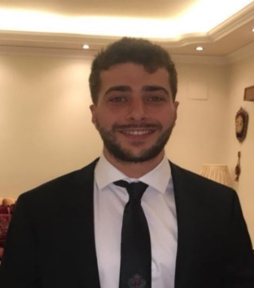
Abdelwahed

Nationality: Lebanese
Location: Dubai, UAE
Email: abdelwahed-396714@gulfjobseeker.com

Career Target: Structural/Civil Engineer

- Recent Structural Engineer graduate with related hands-on experience in the design team sector analysing calculation designs, conducting site visits, and assisting with technical reports

- Detail-oriented professional with an eager to learn mentality for new information and technologies. Possesses sound communication, leadership, and problem-solving abilities. Multilingual

- Seeking an Entry Level Structural/Civil Engineer position at a well reputable company that allows for creativity, diversity, and provides a teamwork environment to assist with my development as an engineer and as a professional

Education

MSc in Structural Engineering September 2019
Brunel University London, United Kingdom; Graduated with 2:1 Merit

Course Highlights
- Structural Retrofitting technology
- Structural dynamics and seismic design
- Advanced steel design

- Pre-stressed Concrete design
- Finite elements design
- Transportation Design

BSc in Civil EngineeringMay 2018
University of Balamand, Lebanon; GPA: 3.0/4

Freshman in Sciences September 2014
University of Balamand, Lebanon

High School Diploma May 2013
International School of Al-Koura, Lebanon

Work Experience

Internship
Lebanon // May 2018- August 2018
- Assisted in producing AutoCAD drawings of structural members to assist senior members of the team
- Regularly visited the construction site to oversee the progress of structural members from inception to completion and to ensure the project was on track
- Ensured that the labourers followed procedures correctly, such as adequate vibrations to concrete members, curing and sealing the concrete properly, and ensured steel fixation was up to standards
- Secured all health and safety requirements were present on-site according to the HSE guidelines, from PPE, safety nets, and site boundaries

Projects

Design of a 12-story high-rise building (Bsc Project)
- Designed a 12-story high-rise building with a two-floor underground parking structure using concrete. The project involved producing drawings of the building using AutoCAD, designing of structural members using BIM software (Revit), estimation of the bills of quantities of the project, and providing an outline on how to develop the security and safety guidelines for the people on-site

MSc Dissertation – Influence of a bio-waste material on water absorption and compressive strength of concrete
- The study emphasised on assessing the performance of a bio-waste material applied on concrete, with different w/c ratios and different concentrations applied to the overall mixtures, at the mixing stage. Tests involved a microscopic examination (SEM) in evaluating the microstructure of the specimens, a compressive strength test to assess the influence of the treatment on concrete’s strength, and lastly, a water absorption test was conducted to assess the resistance of treatment to absorb water

Kings-Gate Bridge, Norfolk - UK
- I have participated in designing a reinforced concrete bridge on a university project with the help of Carey’s Group. As the Project Manager, I was responsible for assigning different teams such as surveying, steel fixing, power tools, health and safety, and I also had to monitor each team’s progress. Furthermore, I had to organise team meetings to discuss our daily tasks and objectives to ensure everyone understood their roles clearly in order to deliver the project on time

Key Skills
- Structural design calculations for concrete, and steel structures
- Ability to produce structural designs using BIM software (Revit)
- Proficiency in AutoCAD, Civil 3D, and ETABS
- Beginner in TEDDS
- Familiar with Eurocode, British, and American Codes
- Technologically oriented, and excellent in MS office/excel
- Excellent communication and time management skills
- Strong analytical and problem-solving skills

Languages
- Fluent in Englishand Arabic
- Proficient in French

Volunteer Experience
Lebanese Red Cross // Tripoli, Lebanon // Jan 2016 – May 2016

I have developedessentialverbalcommunicationskillsthroughworkingwithateam in very high-pressurescenarios whereeffectiveresponseswereimperative, giventhetime-critical natureofthework carriedout

Clubs and Societies
Engineering Society, Math Society, Football Club

