HARJINDER
Nationality:INDIAN
Email:harjinder-396737@gulfjobseeker.com
Availability:ASAP

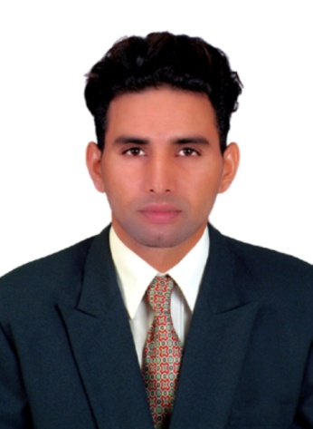
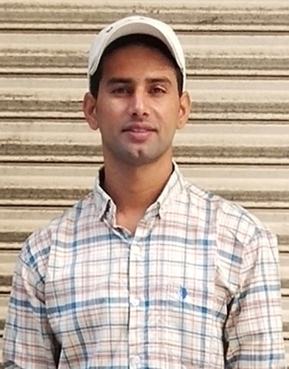
Ashishbhatt

Carrior Objective:-
- I aspire to excel in my professional while contributing actively to organizations mission my presence for learning morecombine with my confidence will definitely help meeting various challenge sat my work place.
EDUCATION & PROFESSIONAL DEVELOPMENT
MATRRIC (10th)
- I have completed 10th SchoolfromP.S.E.B. in 2010, Mohali (Punjab)
SENIOR SECONDRY (10+2)
- I have completed 10+2. From Govt.h.s. school from P.S.E.B. in 2012.Mohali (punjab)
SHORT DIPLOMA COURSES
BASIC COMPUTER 6 month COURSE IIT DELHI 2012
I have completed Graduation from Govt. Rajindera College, Bathinda 2012-15
CERTIFICATE'S
- Deck Rating(Merchant Navy) I.M.E.S. Pvt. Ltd. Chennai In march 2016
- Micronesia Seaman book
- Fire fighting SECURITY Certificate
- Fire safetySECURITY Certificate
- First aid SECURITY certificate
- Self support SECURITY Certificate
- Crowd control SECURITY Certificate
- stcw-2010
- Yellow fever vaccination
- International passport(all valid documents)
1 yr experienceas a VIP security in New Delhi.
2yr(2017-19) of experience as a security Guard at Royale deltin, CruiseShip, Mumbai.
(2016-17)As a able Seaman 9month on Vander bunga oil tanker in malasiya, Singapore, and Thailand
Security Guard
DATE OF BIRTH: 4th April 1993
SEX : Male. HEIGHT: 6”feet
RELIGIO N : Sikh. Weight : 66kg
NATIONALITY : Indian
LANGUAGE KNOWN: English, Chinese,urdu, Hindi, Punjabi
HOBBY : Exploler new things
Blood Group O+

Date. YOURS FAITHFULLY,

Palace:-Dubai HARJINDER

