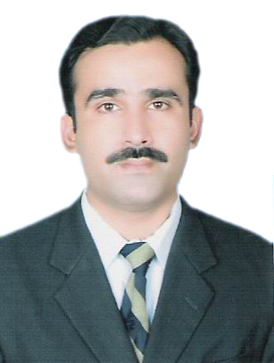
Mr. Mustansar
Lahore Pakistan
Email: mustansar-396749@gulfjobseeker.com
PERSONAL INFORMATION

Date of Birth |  | 27th July 1977
Qualifications |  | B.Com (Bachelor In Commerce)
Last Role  Objectives |  | Sales Executive  Administration, Operations,Office Management,& Sales Related Jobs
Nationality |  | Pakistan

PROFESSIONAL PROFILE:
I am a self-started and motivated business professional with a successful track record of 16 years in Operations, Procurementand Sales.

My objective would be to utilize my education, experience and skills to the upmost in an organization with potential environment.
WORKING EXPERIENCE:
- Sales Executive  (December 2008 to April 2016) | AIM Industries LLC  Dubai UAE  (Concreate Product Manufacture)
- Sales Executive  (July 2016 to August 2018)  - Sales Executive  (December 2018 to May 2019) | Branch of AIM Industries Co  Jeddah KSA  (Concreate Product Manufacture)  (Real Estate Marketing )
Duties & Responsibilities:
- Organizing sales visits on weekly basis
- Demonstrate and present products & services
- Establish new business opportunity thru networking, cold calling and referrals
- Reviewing monthly and Quarterly sales performance
- Aim to achieve set monthly or annual corporate Sales targets.
- Generates sales reports both pre and post sales calls and ensure that all the market information and opportunity are given to management with recommendations
- Builds and maintain mutually beneficial relationship with both the customers and the principal ensuring that the highest level of customer service is provided.
- Participate in marketing and business development activities to create/execute sales collateral, presentation materials, advertising and PR campaigns, tradeshow appearances, promotional campaigns, and customer/prospect mailings
- Contribute new ideas, approaches or techniques for sales and marketing, while keeping up-to-date on relevant industry trends, technologies and competitive product offerings.
- Processing inquires by phone, fax, email and personal visits; Meeting customers to discuss their requirements; Working to maintain good relations with customers.
- Collect outstanding from trade in time so as to maintain debtors to sales ratio as per company policy.
- Reservation Booking Assistance  (April 2002 toDec 2008) | Pakistan Railways  Lahore - Pakistan
Duties & Responsibilities:
- To done the all type of computerized reservation Advance/Current rail ticket.

- Prepare the daily CR note handling the cash.

- Preparation the bank voucher Journal/Receipt/ payment.

- Recovery supervisor  (Jan 1999 to June 1999) | Standard Charter bank  Lahore - Pakistan
Duties & Responsibilities:
- To supervise the customer A/c
- Follow the customer by phone ,mail and goes in to the field. .
PROFESSIONALSKILLS:
- Proactive by nature
- Exceptional organisational skills
- Mastering written and verbal communications skills.
- Ability to work under pressure and tight deadlines
- A can-do attitude, with a passion for process improvement and good problem solving skills.
IT& PROGRAMMING LANGUAGES KNOWN:
- Strong proficiency in MS Office, Window Installation & Hardware Application
- Expert in Development Tools like C/C++, Visual Basic, MS Front Page, Oracle, SQL, Server 7
- Expert in Programming Languages: Turbo C++, Visual Basic, JAVA,SQL .
- Expert in using the tally 9ERP software for accounting.
QUALIFICATIONS:
- MSC (Master in Computer Science) from Scholars Group of Colleges Lahore, Pakistan
- B.com (Bachelor in Commerce) from Punjab College of commerce Lahore, Pakistan.
LANGUAGES:
- Fluent English
- Basic in Arabic
- Native in Urdu
References:
Details will be provided upon request.
Note: I hereby witness the above mentioned information is accurate and is not of false nature.

