CONTACT DETAILS

Email:

Suhai-396767@gulfjobseeker.com

Personal Details

Date of Birth : 13th June1996

Marital Status : Single

Nationality : Indian

Languages Known

- English

- Tamil

Passport Details

Date of Issue |  | : 30 Nov 2015
Date of Expiry : 29 Nov 2025
Visa Status |  | : Visit Visa

PERSONAL RESUME
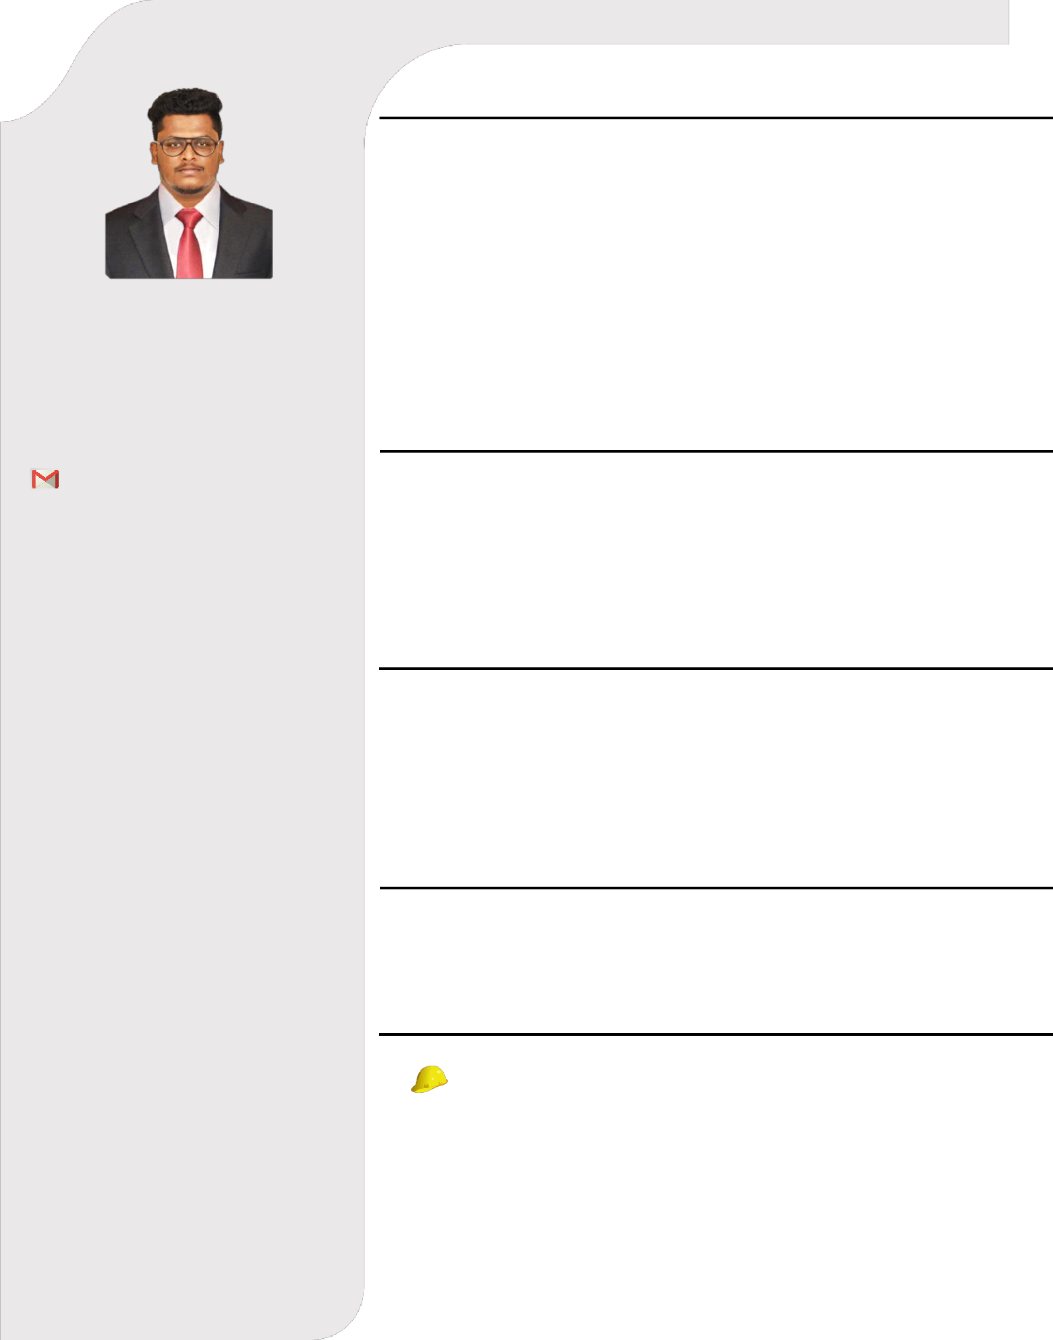

Suhail

Career Objectives

I Would Like To Contribute to the company’s Growth and Prove to be a valuable asset to the Organization. To Work with Full Dedication in Challenging Atmosphere, while adding some Significant values to the organization and gain professional Skills while working with support of competent peers and guidance leader which will further enhance my career ambition of rising to pinnacle of success.

Academic Qualifications

- Bachelor of Mechanical Engineering Anna University, India.

- Higher Secondary Certificate,

Quaide Millath Matric Hr. Sec. School, Tamil Nadu.

Academic Projects

- Design and Fabrication of ELECTRO MAGNETIC ENGINE Presented in B.E., Mechanical Engineering – April 2017.

- Analysis of CARBON SHEET COATING Presented B.E., Mechanical Engineering –April 2018.

Professional Trainings

CERTIFICATE IN PRODUCT DESIGN issued by CADD CENTER-2018, Tambaram, Chennai (Student ID – M 180245646).

Professional Experience

Designation : AutoCAD Draftsman & Product
Testing Engineer

Duration : 10 Aug 2018 To 28 Jul 2019

PERSONAL RESUME

Computer Proficiency

- AUTO CADD

- REVIT MEP

- SOLID WORKS

- MS OFFICE

Industrial Visit

- Visited Ashok Leyland for the reviewing of Production and Manufacturing details, located in Tamilnadu.

- Visited Integral Coach Factory – Perambur For Reviewing the Factory Production Unit and Railway Machineries.

Skills

- A High level of Technical and Machinery knowledge and the ability to apply to knowledge to practical Problems.

- Good oral communication skills and confidence in dealing with a range of people.

- Experience with Analytical and Design software, Such as Revit MEP and Solid Works.

- Excellent Critical Thinking Skills to identify alternative and approaches to solution to complex problems.

DECLARATION

I hereby declare that the above written particulars are true to the best of my knowledge and belief. Pertinent Documents and references are to follow upon request.

Suhail

