ATHULYA 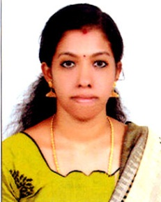
Email: athulya-396770@gulfjobseeker.com
Visa status : Visiting

Looking for a suitable job in an organization where I can use my knowledge and skills for the benefit of the organization. Also enhance my personal growth through continual upgrading of
knowledge

W ORK EXPERIENCE

Position | Accounts Assistance
DateofJoin | 15/05/ 2017 TO19/03/2019
Jobdescription | Handling the creditors, petty cash, day to day operations and construction Accounting of theHospital

ACADAMICS

SLNO | COURSE | CGPA | UNIVERSITY | INSTITUTE
1 | M.COM(FINANCE) 2015-2017 | Course  Completed | MG University | Distant education
2 | BCOM(TAXATION)  2012-2015 | 50% | Kerala University | Presidency college,Charumood.
3 | VHSE BANKING ASSISTANCE  2010-2012 | 70% | Kerala Board | Govt Vocational Higher SeconderySchool, Chunakara

S K I L LS

- Proficient in tally9.2
- word processing andaccounting.
- Advanced Excel,powerpoint.
- ERP 9.2

PERSONAL PROFILE

Date of Birth : 21/04/1995
Marital Status : Married
Known Languages : Malayalam , Hindi, English

Date :

Yourssincerely

Place :

(Athulya)

