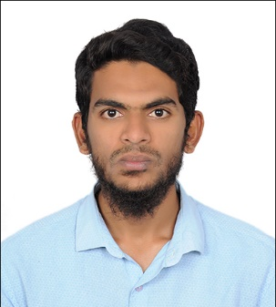
Name: Irshad
Position: Accountant
Experience: 2+ Years
Educational Qualifications: M.B.A
Key Skills:Financial Accounting, Corporate Finance, Budgeting,Forecasting, Financial Derivatives, Microsoft Excel,Critical thinking & problem solving
Current Location: Dubai, UAE
Availability: Immediate
Visa Status: Visit Visa
Email: irshad-396773@gulfjobseeker.com

Summary of Career
- 2+ Years of experience in Financial Accounting.
- Detail-oriented, efficient and organized professional with extensive experience in accounting systems.
- Possess strong analytical and problem solving skills, with the ability to make well thought out decisions.
- Possess multiple skills covering many financial areas such as laws, cost control principals, ledger analysis, financial statements, budgeting, taxation and economic regulations.
- Excellent written and verbal communication skills.
- Resourceful in the completion of projects, effective at multi-tasking.
Achievements
- Completed project successfully on ‘Financial Derivatives’ in Indiabulls Securities Limited.
- Awarded as ‘League of extraordinary performance’and ‘Star of the Month’ during my work tenure.
Employment History
- Accountant in– November 2017 to January 2020 (2+ years)
Computer Skills / Software Skills
- Knowledge on Tally ERP9.
- Knowledge on Focus tools.
- Good knowledge of Microsoft Excel.
- MS Office & Internet applications.
Employment Records
Job Position : Accountant
Year : November 2017 to January 2020
Roles & Responsibilities:
- Performed accounts payable functions
- Managed financial departments with responsibility for budgets, forecasting, payroll, accounts payable and receivable
- Ensured compliance with accounting deadlines.
- Prepared company accounts and tax returns for audit.
- Liaised with bankers, insurers and solicitors regarding financial transactions.
- Monitored and recorded company expenses.
- Generated budgets and forecasts on a quarterly basis
- Prepared annual company accounts and reports.
Educational Qualifications
- M.B.A. at Indur P.G. College of Business Management, India – 2017
- B.Com (Taxation) at SVS Degree College, India – 2015
- Intermediate at BIE, India - 2012
Personal Details
Date of Birth : 6th May 1994
Nationality : Indian
Marital Status : Single
Languages Known : English, Hindi & Urdu
Declaration
I, hereby declare that the above particulars furnished by me are true to the best of my knowledge and belief.

Name
(Irshad)

