SALIH
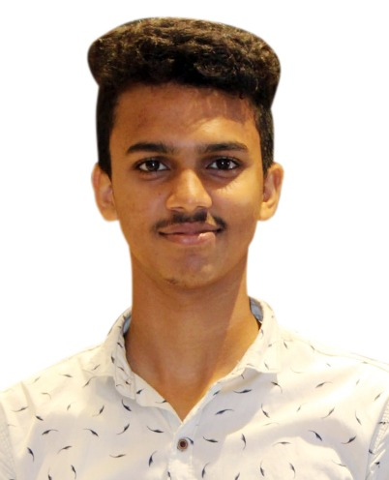

Email id: salih-396781@gulfjobseeker.com

CAREER OBJECTIVE

Exploring career opportunities in the to utilize Sales, Account Assistant and Public Interfacing abilities in a challenging Business Development Sales assignment.

EDUCATIONAL QUALIFICATION

COURSE | UNIVERSITY/BOARD | YEAR OF PASSING | PERCENTAGE
DIPLOMA IN ACCOUTANT | Gurukulam Computer Center , Kerala | 2019 | 80 %
PLUS TWO  (Computer Science) | Higher Secondary Examination, Kerala | 2018 | 64 %
S.S.L.C | Board of Public Examination Kerala | 2016 | 78%
EXPERIENCE:
(2019-Training)
- Worked as Office Assistant for 3 Months.
- Worked as Accounts Assistant for 3 months.

(2019-present)
- Worked as accountant for 1 Year.
- Worked as cash for 1 Year.
(ACCOUNTING 1 YEAR EXPERIENCE).

COMPUTER QUALIFICATION
- TALLY
- QUICK BOOK
- PEACHTREE
- TRADESEY
- MYOB
- EXCEL
SKILS
- MS OFFICE,EXCEL,TALLY KNOWS BETTER.GOOD EXPERINCE.
PERSON DETAILS
Name : SALIH
Date of Birth : 29-12-1999
Age : 20yrs
Gender : Male
Nationality : Indian
Religion : Islam
Languages Known : English, Malayalam
Marital Status : Single

DECLARATION
I do here by declare that the above information are true and correct to the best of my knowledge and belief.

PLACE :MATTANUR

SALIH

