ALAGU

B.E MECHANICAL ENGINEERING
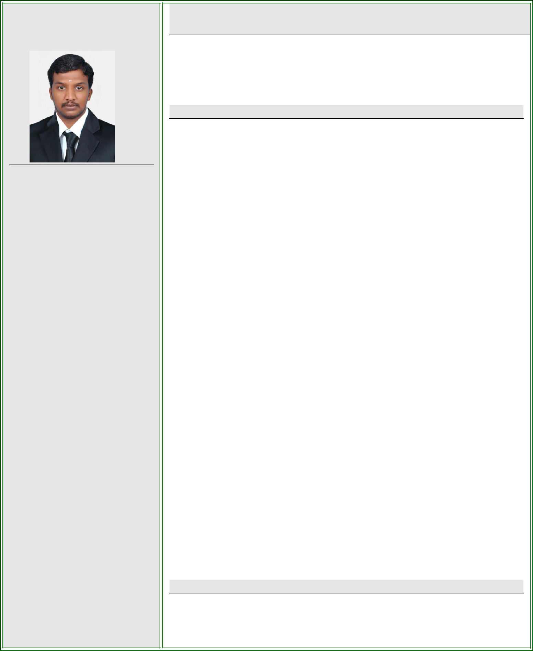

PERSONAL PROFILE

Email:
Alagu-396793@gulfjobseeker.com

Personal Data:

 | Gender | : Male
 | Date of Birth | : 17-01- 1992
 | Marital Status | : Single
 | Nationality | : Indian
 | Visa status | : Visiting Visa
 | Visa exp Date | : 30/04/2020
Passport Details:

 | Date of Issue | : 30/12/2013
 | Date of Expiry | : 29/12/2023
Languages Known:

- English -able to read, Write & Speak,

❖ | Tamil | -able to read, Write & Speak,
❖ | Telugu | -able to speak only.

CAREER OBJECTIVE

- To pursue a successful, challenging & exciting career and also able to dispense my maximum potential to the benefit of the organization but at the same time to acquire knowledge on the road to success.

PROFESSIONAL EXPERIENCE

AS SERVICE ENGINEER – III FROM 08.12.2014 TO 23.01.2020

This company was established in 1911. It is the holding company and is a diversified Group in the automobile field. While the core businesses also include auto components manufacturing & distribution, logistics etc., the company is known for its presence in automobile distribution in more than seven states. The company has attained a turnover of USD 1 billion (over INR 4,000 cores) and has employee strength of 5000.

ROLE AND RESPONSIBILITY:

- Working as Technical Service Engineer in Ashok Leyland vehicle service division.

- To control 15 number technician team and regulate their job.

- Made technician allotments for vehicles based on work and skill requirement.

- To monitor technician work activities and help them technically to complete their job.

- Frequently monitor parts store for material requirements.

- To train technicians to update new model vehicles.

- To provide technical support to employees through quality tools like 5S, Lean etc...

- Prepare for regular yearly auditing.

- To develop new tools for employees to simplify the working load.

- To monitor total STO (Service Turn Over) and analyze time taken for a single job.

- To provide technical support to parts department through MSL analysis and ABC (Always Better Control) methods.

EDUCATION
- BACHELOR OF ENGINEERING Degree: Mechanical Engineering from

TCET,(ANNA UNIVERSITY, INDIA)

SOFTWARE SKILLS
- AUTOCAD

- PRO- E

- CATIA

- ANSYS

- SAP

STRENGTHS
- Ability to analyze problems/ Issues.

- Committed and devoted towards work.

- Open minded to work in complex environment.

PERSONALITY TRAITS

- I would describe myself as a passionate, highly motivated person who is ready to tackle any challenge. I am determined to succeed, to improve myself and to expand on all of my skills and talents whenever the chance arises. I am very friendly and insist on making friends with everybody that I meet.

AREA OF INTEREST
- Vehicle service Supervisor

- Site Engineer & Supervisor

- MEP Designing

- Building Maintainance

DECLARATION

- I am familiar with Mechanical Engineering aspects. I am also confident of my ability to work in any team. I hereby assumed you sir that the information furnished above is true to the best of my knowledge and belief.

Place : Dubai.

Date : (ALAGU)

