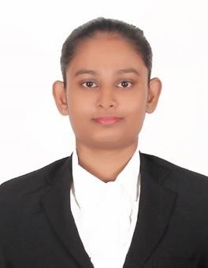CURRICULUM VITAE

Dilani

PERSONAL DETAILS
Date of Birth : 04th of November 1996
Age : 23 Years
Religion : Buddhist
Marital status : Unmarried
Gender : Female
Nationality : Sinhala
School Attended : R/Convent of the Child Jesus National School (Girl’s) - Rathnapura

EDUCATION QUALIFICATION

G.C.E. (O/L) Examination in 2012 Index No - 22068368

Subjects Grade
Buddhist A
Sinhala A
Health A
Citi. Edu. B
History C
Science C
English C
Mathematics S
Art S

G.C.E. (A/L) Examination in 2015 Index No. - 5262011
Z-Score - 0.7436

Subjects Grade

Sinhala A
History C
Home Economics C
English S

OTHER QUALIFICATION

  - Successfully completed Higher National Diploma in English Sri Lankan Institute of Advance Technological Education (SLIATE)-2017
  - Successfully completed National Certificate in professional English Course in Technical College (NCPE) - 2016
  - Successfully completed Business Management and Human Resource Management Course in Sri Lanka Institute of Management Development.
  - Successfully completed six months English Teacher Training in government school. (R/Pussella M.V)
  - Successfully completed Information and Communication Technology general certificate course.
  - Following Business Management and Human resource management Diploma in Sri Lanka Institute of Management Development.(LIMD)

LANGUAGE PROFICIENCY
  - Fluent in speaking, reading and writing in Sinhala.
  - Fluent in speaking, reading and writing in English.

Personal Contact : dilani-396798@2freemail.com
Reference : Mr. Anup P Bhatia, HR Consultant, Gulfjobseeker.com 0504753686

I do hereby certify that the above stated particulars are true and correct to the best of my knowledge.

25-01-2020 .
Date

