Summary
PRINCE PAUL

15

PERSONAL PROFILE
Date of Birth : 25 - 09 -1993
Father’s name : SASIKUMAR
.PG
Gender : Male Marital status : Single
Passport No. : P6743627 Date of expiry : 05 - 02 - 2027

SOFTWARE SKILLS

Auto CAD -----
------
Revit -----------
-------
HAP ------------
--------
Microsoft office ---
MATLAB ------
--------

To seek a career in an organization having challenging and creative environment with committed and dedicated people that will help me to implement my skills and talents for the growth of the organization.

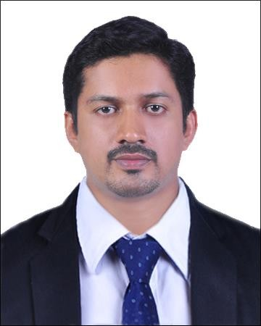PRINCE

PERSONAL PROFILE

Date of Birth /Age: 28 - 07 -1990
/29 Years

Gender: Male
Marital status: Single Nationality: Indian State: Kerala

SOFTWARE
SKILLS:

Auto CAD -----

Revit ----------
HAP ------------
Microsoft office ---
MATLAB -------

MEP & AUTOCAD CERTIFICATIO NS.

Visa Type: UAE Visit Visa Valid until: 05/May 2020

Experience

Electrical Quality Engineer - August/2015 to February/2020 Avacend Solutions Pvt Ltd
Work location: Kerala, India

- Installation, Testing and Commissioning and Quality assurance of Power plants, Battery Banks, Diesel Generators & Control Panels, SMPS, LT Panels, ACDBs, DCDBs, HVAC, Earthing system & other electrical equipment’s.
- Preparation of SLD’s, Load List, Equipment Sizing Calculations, Specifications and Datasheets, Control Schematics, Cable Sizing Calculation and Schedule, Cable Tray Layout, Lighting Calculation and Layout, Earthing Calculation and Layout, Lightning Protection Layout, HVAC, Material BOQ, Load Flow, Short Circuit and Motor Starting Studies.
- Power &Telecommunication Layout based on design drawings.
- Reviewing, Commenting and approving of Vendor drawings and documents.
- Do random site inspection. Follows all checklists and procedures, including Safety.
- Coordinating with Customer and Vendor teams in resolving issues related to project.

MEP Engineer – June/2013 to July/2015 Wintek Electrical Consultants & Contractors. Work Location: Cochin,India

  - Ensure that the installation, inspection and testing of all the MEP equipment, fittings and work implemented meets the specification and the consultant requirements.Verify the accuracy of shop drawings and their compliance to the specification, consultant’s design and existing local authority standard
  - Perform ongoing Preventive Maintenance and Repair work on facility Electrical,Mechanical and other installed systems.
  - Safe and smooth operation and maintenance of various electrical equipment viz. HT & LT Switchgear Panels, Power and Distribution Transformers, Diesel Generators and LT motors, Circuit Breakers, VCB, ACB, Battery charging unit, Battery banks, UPS, Plant Lighting, HVAC, AHU Units relays etc.
  - PCC & MCC Panel Boards, Generator AMF Panels, Metering Panels, ACB Panel Boards.
  - Prepare summary reports of conditions in buildings and recommend actions to be taken.
  - Comply with all Safety procedures and requirements.
ACADEMIC QUALIFICATION

Examination | Discipline | School/College | Board/University | Year of  passing/Percentage
B-TECH | Electrical & Electronics Engineering | Mar Baselious Christian College, Eng&Tech,Peermade | Mahathma Gandhi University | 2013 / First class
Plus 2 | Computer Science | O.L.L H.S.S Uzhavoor | Board of Higher Secondary Examination | 2008 / 74%
SSLC | SSLC | St.Annes HSS Kurianad | Board.of Secondary Examination | 2006 / 86%
SELF-APPRAISAL

  - Good communication skill.
  - Ability to initiate actions & perform critical tasks effectively and timely.
  - Strong believer of achieving results through Communication and Experience.
  - Team-working skills. Capable of working under pressure
  - Updated with emerging technologies.

Personal Contact : prince-396803@2freemail.com
Reference : Mr. Anup P Bhatia, HR Consultant, Gulfjobseeker.com 0504753686

DECLARATION
I hereby certify that the above information is true and correct to the best of my knowledge and belief.
Place: Monippally PRINCE
Date: 06/02/2020

