WORK EXPERIENCE

NATIONALITY: DATE OF BIRTH: MARITAL STATUS: LANGUAGES: VISA STATUS:
PAKISTAN 1986-09-25 SINGLE
URDU, ENGLISH VISIT
2012
2013

2013
2015

2017
2019

ALLAM HAYAT HOSPITAL (DR MUHAMMAD ASIF ASHRAF M.B.B.S
working in my hospital as dispenser, clinical assistant and dresser.
DESCON ENGINEERING LIMITED
Worked as SAFETY OFFICER at Pakistaion Oil Refinery Project.
SADIQ FEEDS (PVT) LIMITED
Worked as SAFETY OFFICER at Sadiq Feeds (PVT) limited Sahiwal, pakistan

SKILLS

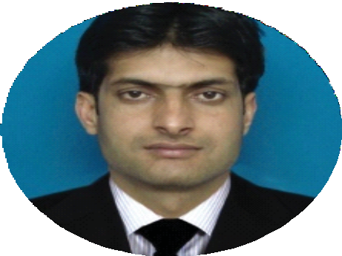
EDUCATION
2007
2010
DAE MECHNICAL TECHNOLOGY
punjab board of technical Education Lahore.
2003 MATRICULATION (SCIENCE)
Board of Intermediate & Secondary Education Multan.

2015
AZAM
Dedicated and driven safety officer committed in ensuring the safety and security of the people in the workplace by establishing and providing procedures and policies for a safe environment.
MANAGING SAFELY (IOSH)
Institution of Occupational Safety
2015 CONSTRUCTION SAFETY
Saeed Ahmad Awan Center for the improvement
2004
2005
2010
2012
working conditions & environment
CLINICAL ASSISTANT (FIRST AID)
punjab vocational training Council lahore
PHARMACY TECHNICIAN / ASSISTANT PHARMACIST
punjab pharmacy councial lahore.
PERSONAL DETAILS

CONTACT

azam-396833@2freemail.com

Mr. Anup P Bhatia, HR Consultant, Gulfjobseeker.com 0504753686
396
Deira Dubai UAE
Ms, Oﬃce
Excellent Decision-making Skills Focused and Determined
Safety Management and Operations Strong Familiariaty with Safety Equipments Strong Ability in ﬁrst Aid
Internet Knowledge
knowledge in conducting safety training

