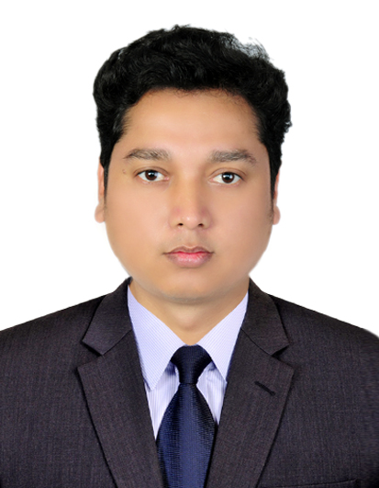
ABHISHEK

Email: abishek-396842@gulfjobseeker.com

--------------------------------------------------------------------------
OBJECTIVE's

TO ENHANCE MY PROFESSIONAL SKILL IN DYNAMIC AND PACED WORKPLACE AND TO USE MY SKILL IN THE BEST POSSIBLE WAY FOR ACHIEVING COMPANY'S GOAL'S.
To secure a challenging position as an Accountant where extensive experience will be further
Developed and utilized.

PROFESSIONAL EXPERIENCE

A COMPANY OF FINE DINNING RESTAURANT LAUNCHED ON 2014 PROMOTED BY INDIGO KNOWN BY THEIR REPUTATION.

APPOINTED AS GUEST RELATION ASSOCIATE ON MAY,2014,OVER THREE MONTH TRAINING WITH AYEAR OF WORK PERIOD .
IMPLICATION OF F&B AND TECHNICAL SKILLS OF HANDLING ACCOUNTING C UNTERS

DESIGNATION: GUEST RELATION ASSOCIATE (GRA)
WORK PERIOD: 2 YEAR .

KAVERI RESTAURANT

A FAMOUS RESTAURANT AT LOCALITY OF RANCHI.

APPOINTED AS SENIOR GUEST RELATION ASSOCIATE ON OCTOBER 2016,OVER THREE MONTH TRAINING WITH AYEAR OF WORK PERIOD .
IMPLICATION OF F&B AND TECHNICAL SKILLS OF HANDLING ACCOUNTING COUNTERS .

DESIGNATION: SENIOR GUEST RELATION ASSOCIATE .
WORK PERIOD: 2 YEAR.

EDUCATION

LALA LAJPAT RAI SR. SEC. SCHOOL.
PUNDAG,RANCHI,JHARKHAND.

SITUATED IN PUNDAG AT RANCHI DISTRICT OF JHARKHAND PRIVATE ENGLISHMEDIUM SCHOOL IN NAME OF LEGENDARY FREEDOM FIGHTER.

CERTIFIED: MATRICULATION (10TH) (SSC).
(CBSE)

GOSSNAR COLLEGE ( JHARKHAND).
RANCHI , JHARKHAND.

AN JHARKHAND ACADEMIC COUNCIL COLLEGE SITUATED IN RANCHI ATJHARKHAND

CERTIFIED :INTERMEDIATE (JAC)

: GRADUATION (JAC)

ADDITIONAL SKILLS

POSSESS EXCEPTIONAL COMMUNICATIONAL AND INTERPERSONAL SKILLS AND ABILITIES.
CAPABLE OF PERFORMING MULTIPLE TASKS EFFICIENCY.
EXPERT IN WINDOWS AND EXCEL.
Detail-oriented, efficient and organized professional with extensive experience in
Accounting systems.
Strong analytical and problem solving skills.

Computer Skills

  - Operating Systems : Windows 2000, Windows XP, Windows Vista
  - Office Package : Tally ERP, Microsoft Word, Excel, Power point,

PERSONAL PROFILE

- DATE OF BIRT : 29TH APRIL,1983

- NATIONALITY : INDIAN

- MARITAL STATUS : SINGLE.

- BLOOD GROUP : B+

- LANGUAGE m : HINDI , ENGLISH , NEPALI.

- UAE VISA STATUS : VISITING.

DECLARATION

I hereby declare that the above-mentioned information is correct up to my knowledge and I bear the
Responsibility for the correctness of the above-mentioned particulars.

ABHISHEK
Date: - ………………
Place:

