CURRICULUM VITAE

Dilshad

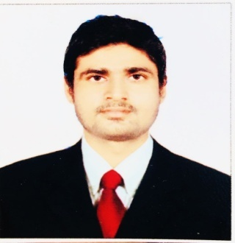

Email:- dilshad-396844@gulfjobseeker.com

CARRIER OBJECTIVE

To work in a challenging Environment to acquire knowledge, enhance my skills and contribute to the growth of the organization.

SYNOPSIS

I have05 Years experience's H.V.A.Con SiteWork and Maintenance Work commercial and residential as aH.V.A.C TECHANICIAN.

- Technical and Analytical skills, good at problem solving.
- Good verbal and written communication skills.

EDUCATIONAL QUALIFICATION : -

10th with aggreate(1st Division ) from BSEB Board Patna
12th with aggreate(1st Division ) from BSEB Board Patna.
B.Tech with aggreate(1st Division) from JNTU Hydrebad
WORKEXPERIENCE'S : -

Company Name | Designation | Period
Voltas Limited | HVAC Technician | 2015-2017
 | HVAC Technician | 2017 to Till Date
WorkResponsibility:-
Installation &Maintenance : -
>Chiller ,Ahu/Fcu , Installation & Maintenance
>VRV and VRF Installation & maintenance
> Duct Installation of AHU/FCU.
> Basement Normal & Fire Ventilation
> Window and Split Installation and Maintenance.

WORK PROFILE INCLUDES : -
- Reading Drawing
- Heat Load Calculations ( By E-20 sheet )
- Selection Of Equipment's for low side ( AHU / FCU )
- Duct sizing (Using Ductulator)
- Chilled water & Condenser Water Pipe Sizing and Routing.
- Ventilation & Exhaust of the Basements in Normal & Fire conditions.
- VRV/VRF Installation and maintenance.
- Split and Windows ac installation and services.
- Chiller Installation and Service's.
- Duct Installation Basement Ventilation

TECHNICAL SKILLS

Computer Program:-DCA,Ms-excel,Ms-office

STRENGTH
Determined to learn with practical approach
Dedicated, hardworking individual
Fast Learner, Team worker

PERSNAL DETAILS

Name: Dilshad
Sex: Male
Material Status: Single
Language Known: Hindi, English.

DECLEARATION

I hereby declare that the above particulars are correct to the best of my knowledge and belief.

Place: Mumbai Date:
Dilshad

