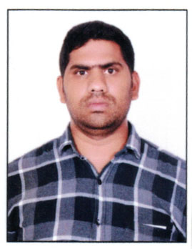
CURRICULUM-VITAE

SANTHOSH
SAFETY OFFICER
E-mail: santhosh-396853@gulfjobseeker.com

OBJECTIVE:
“Seeking a Challenging and responsible position where my education abilities and potential can be effectively utilized, and which offer opportunities for growth, to acquire more knowledge and to serve in building the nation in the best way”

WORKING EXPERIENCE:

- Safety Officer ( Hyderabad) May-2019 to Till Now
- Rabban Readymix WLL, Safety Officer ( Qatar ) Dec-2015 to Oct2018
- NCC Ltd, Safety Officer (Hyderabad) Jun2012toAugust2015
- Al Turki Cement Products LLC, Safety Officer ( Oman) Dec-2008 to Feb- 2012

EDUCATIONAL AND TECHNICAL QUALIFICATION:

- Bachelor of Arts Degree at Kakatiya University( 2006)
- Board of Intermediate Education (2003)
- Secondary School Certificate (2001)
- Diploma in Fire&Safety(2007)
- Institution Of Occupational Safety and Health (iosh) 2019
- NEBOSH International General Certificate in Occupational Health and Safety (IGC 123)2019

TECHNICAL:
Computers: Post Graduate in Diploma Computer Applications (PGDCA),

SAFETY OFFICER JOB RESPONSIBILITES:

- Continuous inspection of project sites, to ensure a hazard-free environment
- Assessment and approval of subcontractor safety plans
- Verification of tools and equipment to ensure good quality
- Promoting safe practices on site
- Creating and enforcing safety guidelines and programs
- Carrying out drills and exercises on managing emergency situations
- Conducting investigations on accidents
- Verifying that all safety reports are submitted to related government institutions.
- Responding to workers’ safety concerns
- Manages all communications with government departments in regards of safety
- Arranges OSHA-mandated evaluations of the site
- Coordinates all issues regarding hazardous materials or waste
- Assisting with the preparation of a construction health and safety plan
- Attending project planning meetings and collaborating with construction managers
- Establishing and maintaining health and safety communication structures
- Testing effectiveness of site emergency response plans
- Continuous monitoring of all safety related documents, reports and issues to keep them updated.

PERSONAL DETAILS:
Name SANTHOSH
Date of Birth 15-06-1985
Marital Status Married,
Nationality Indian
Languages English, Hindi & Telugu

DECLARATION:
In the above facts are true and correct to the best of my knowledge. If you could give a chance to work with you, I assure that I will discharge my duties to the entire satisfaction of your organization.

Date:

Place: Hyderabad (SANTHOSH)

