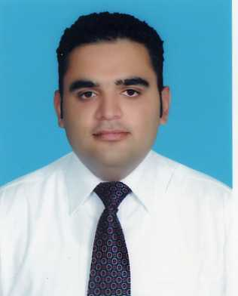
ARSLAN

Email: arslan-396863@gulfjobseeker.com
DOB: 01-01-1988 – Married

Career Objective:
To work for a reputed organization which fosters a competitive environment and where personal growth and career enhancement is encouraged.

Personality Traits:
Have ability to successfully manage multiple priorities and assignments. Establish and maintain good public relations at workplace. I have ability to handle pressure and deadlines effectively. Self-motivated and strive for continuous personal and professional improvements.

Academics:
Degree | Institution
Master Of Business Administration  (Finance & Marketing)  2008-2010  Bachelor In Commerce  2006-2008  Intermediate In Commerce  2004-2006 | Superior University Lahore, Pakistan.  2.7 CGPA  Superior Group Of College Lahore, Pakistan.  2nd Division  Superior Group Of College Lahore, Pakistan  2nd Division
Professional Experience Summary:

 | Department | Designation | Duration
 | Accounts | Accounts Officer | (June 2014 – March 2019)
Job Description:

As account office, my core responsibilities were providing financial Services in order to ensure effective, efficient and accurate financial operations within an assigned time. Primarily, I am responsible to perform the following functions;

- Processing Journals and Ledger accounts accurately and in a timely manner.
- Processing and monitoring of payments and expenditures to ensure that finances are accurate and up to date in project based environment.
- Preparing cash payment voucher (CPV) and bank payment voucher (BPV) on daily basis.
- Closing Books of Accounts On monthly basis.

- Keeping record of all business transaction (cash and credit) and providing accurate and satisfactory data when needed to top management.
- Ensure Control accounts are in balance at all times and reconciling them on monthly basis.

Organization | Department | Designation  ( March 2011- May  2014 ) | Duration
Rana Trading Co. (Royal Tag Importers) | Accounts | Accounts Officer

Job Description:

As accounts officer, I was directly reportable to manager accounts. The overall journal ledgers were under my responsibility. My key tasks and activities were;

- Supervision and recording of routine transactions.
- Maintenance of expenditure accounts and preparation of monthly expenditure statement
- Processing and handling cash and credit transactions
- Input of sales and purchases invoices, cross checking on billings
- Preparing of accounts payable and account receivable control accounts.
- Financial operation including cash handling and cash recording.
- Ensure the integrity of general ledgers accounts to the senior management.

Trainings:

- Had internship in Meezan Bank Limited.
- Had training on sales at New Jubilee Life Insurance Company.
- Certification of computer hardware from AusPak College.

Interests:
Playing badminton, driving at high speed, spend quality time with family especially with my son and daughter.
Languages:
English Oral: Good Written: Good
Urdu Oral: Excellent Written: Excellent
Punjabi Oral: Excellent Written: Excellent

Reference:
Will be furnished on demand.

