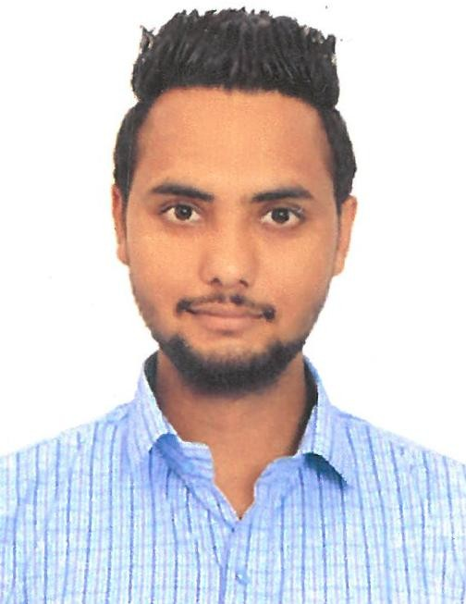

SUKHRAJ
OBJECTIVE:
I would like to join an Organization that is driven to excellence and promotes professional
development based on employee’s efforts, loyalty and work ethics. To have an opportunity to work with a reputed organization and expertise to grow, develop and advance with the organization.
EDUCATIONAL QUALIFICATIONS:
- 12th Passed board of P.S.E.B, Punjab, India in 2009
- High School passed board of P.S.E.B, Punjab, India in 2007

COMPUTER KNOWLEDGE:
- Basic Computer knowledge
- Internet Browsing & Emailing

PROFESSIONAL EXPERIENCE
- Worked as a Security guard in SNP Security Services, Jalandhar, Punjab, India From March 2018 to April 2019

Worked as a Security guard in Delta Force Security Service LLC , Dubai, UAE From November 2019 to 29 December 2019
Duties and Responsibilities:
- Monitoring and authorizing the entrance and departure of visitors, employees and other person’s so as to guard against theft and maintain the security of the compound
- Securing the premises and personnel by patrolling, monitoring, inspecting building equipments and access points.
- Calling for help by sounding alarms.
- Controlling traffic by directing drivers
- Ensuring the operation of equipments by completing preventive maintenance requirements and calling for repairs when accessory
PASSPORT DETAILS:
Date of issue : 05/11/2015
Date of Expiry : 04/11/2025

Visa Status : Employment Visa
PERSONAL DETAILS:
Date of Birth : 15/03/1991
Nationality : India
Gender : Male
Marital status : Single
Languages Known : English, Hindi & Punjabi
Personal Contact : sukhraj-396933@2freemail.com
Reference : Mr. Anup P Bhatia, HR Consultant, Gulfjobseeker.com 0504753686
DECLARATION:

I hereby declare that the above mentioned statement are true and correct to the best of my
knowledge. I will do my best.
Place: Dubai – U.A.E Sukhraj

