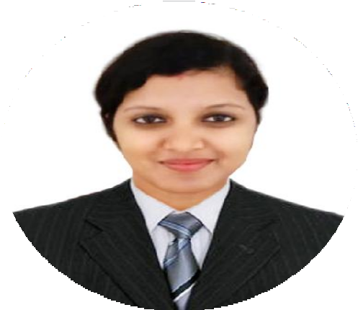 ABOUT ME:
Motivated Associate with 5years of experience. Independent worker with high energy and great enthusiasm, Reliable and friendly professional able to work with little oversight and collaborate in team environments, looking for a suitable and rewarding career in an organization where I can utilize the abilities and skills that I developed through my education and work experience.

MANISHAA

Karama, UAE
WORK EXPERIENCE:
Technical Support Engineer:
Sutherland Global Service Pvt. Ltd., Kochi Kerala, India (November 2018 to September 2019) Job Responsibilities:
- Research division of McAfee and one of the world's leading sources for threat research, threat intelligence, and cyber security.
- Interact with a Wide Range of Customers and Technical Issues.
- Research and identify solutions to software and hardware issues.
- Resolving network issues, configuring operating systems and using remote desktop connections to provide immediate support.
- Track computer system issues through to resolution, within agreed time limits.
- Talk clients through a series of actions, either via phone, email or chat, until they’ve solved a technical issue.
- Follow up with clients to ensure their IT systems are fully functional after troubleshooting.
- Prepare accurate and timely reports and maintain jovial relationship
- Taking ownership of customer issues reported and seeing problems through to resolution.

Customer Relation Management:
JUST DIAL Pvt. Ltd., Coimbatore,
Tamil Nadu, India (July 2016 to April 2018) Job Responsibilities:
- Develop a growth strategy focused both on financial gain and customer satisfaction.
- Conduct research to identify new markets and customer needs.
- Arrange business meetings with prospective clients.

PERSONAL SKILLS:
  - Good communication and presentation skill.
  - Possess great analytical and problem and solving skill.
  - Good team player, flexible and hardworking with sincerity & honesty.
  - Quick learner and Adaptive to changing environment.
  - Positive attitude and self- motivated.
  - Willingness to learn new things

PERSONAL :
  - Date of Birth : 24-03-1992
  - Nationality : Indian
  - Marital Status : Married

Passport Details
  - Date of Issue : 26/April/2018
  - Date of Expiry : 25/April/2028

LANGUAGE SKILLS:
  - English
  - Malayalam
  - Tamil
  - Hindi

AVAILABILTY:
Available for immediate joining

Personal Contact : manishaa-396951@2freemail.com
Reference : Mr. Anup P Bhatia, HR Consultant, Gulfjobseeker.com 0504753686

  - Promote the company’s products/services addressing or predicting client’s satisfaction.
  - Prepare sales contracts ensuring adherence to law-established rules and guidelines.
  - Keep records of sales, revenue, invoices etc.
  - Provide trustworthy feedback and after-sales support.
  - Build long-term relationships with new and existing customers.

Product Information Management: VWR International Pvt. Ltd., Coimbatore, Tamil Nadu, India(June 2014 to June 2016) Job Responsibilities:
  - Provide information for management by preparing short-term and long-term product feature documents and metrics.
  - Rigorously leverage data and analytics to drive decisions, features and design
  - Work with QA engineers to create test plans
  - Overseeing all incoming and outgoing project documentation
  - Participating in tender process i.e. design, submission and review
  - Conducting project review and creating detailed reports for executive staff.
  - Optimizing and improving processes and the overall approach where necessary

EDUCATIONAL QUALIFICATION:
  - Master of Science (M.Sc)-Biotechnology
    - (Bishop Heber College Trichy, Bharathidasan University)
  - Bachelor of Science (B.Sc)-Biotechnology
    - (K.S.G College Coimbatore, Bharathiyar University)
  - Higher Secondary Education, St. Thomas, Palakkad.
    - (Kerala state board of secondary education)
  - Secondary Education (Kerala state board) St. Thomas, Palakkad.

OTHER CERTIFICATION:

  - PGDBI (Post Graduate Diploma in Bio-Informatics), Bharathidasan University, Trichy.

TECHNICAL/SOFTWARE SKILLS:
  - Microsoft Office (Word, Power Point, Excel, Access)
  - Tissue culture, Electrophoresis, Medical coding
  - Data analytics. PIM

