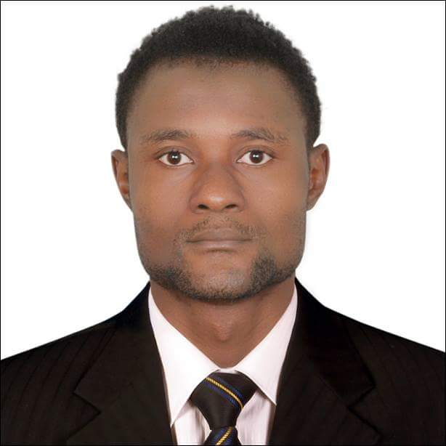
RAHAMAN

Statut: Visit visa
Email: rahaman-396968@gulfjobseeker.com

PHYSICAL EDUCATION TEACHER
SUMMARY
An articulate and confident teacher with a strong passion for students,seeking to leverage more than 4 years of teaching experience. To inspire and serve as a role model to children in achieving fitness and good health; to become a part of the pool of esteemed educators at a well-known ; to promote physical fitness in the school and the community; to mentor obese children and get them into fitness and healthy living.

EDUCATION
- University of Douala
Bachelor of Science Honours degree -Biology (Human and Health Biology) 2013
University of Douala
- Diploma of Science -Biology (Human and Health Biology) 2011

Courses
- First Aid , 2012
- Certificate of completion Drug free Workplace 2019
- Basic Occupational Safety and Health
SKILLS
- Formal training in Sports Education
- Great Excellent interpersonal and leadership skills
- Highly organized and dedicated to work
- Goal-oriented and resourceful
- Great communication skills
- Ability and patience to play with children
- passion and respect for sports and outdoor activities
- Ability to coach different children
- Outstanding problem-solving skills
- Receptiveness to new ideas and other people’s insights
- Great time management skills
- Outgoing and friendly personality
EXPERIENCE
Football Team Goalkeeper coach in School in Al Barsha-part time ,2019-now
PE Teacher, 2015-2017
Saker Secondary School, Douala-Cameroon
Responsibilities
- Encourages students to participate in physical activity even outside of the Physical Education (PE) class
- Motivates children to be active in sports activities of the school and other activities of the community
- Serves as a role model or lead by example in terms of physical fitness and attitude.
- Plans and leads school’s activities and programs in physical fitness programs
- Coordinates with other teachers to promote opportunities for physical activity in the school and community
- Provides training and resources or serve as resource person to classroom teachers
- Assists in supervising and coaching the school’s basketball and football team
- Provides other engaging activities to the students
- Sits on school committees
- Assists the school administration with other school activities, events, and campaigns
Teaching Assistant, 2013-2015
St Bridget College, Bamenda-Cameroon
Responsibilities
- Helped develop instructional materials
- Assist academic staff with various school activities
- Collected data/information as needed by the professors in the department
- Distributed and collected tests and homework assignments
- Graded tests and homework, computed and recorded results, and submitted these to the teaching staff
- Instructed students in the proper use and care of equipment and facilities
- Helped in organizing, supervising, and officiating games and other recreational activities
- Conducted demonstrations to teach skills in sports
- Assisted the librarian and operated audiovisual equipment
- Assisted in maintaining computers in laboratories and classrooms
- Helped students with computer software
- Stocked teaching materials and supplies
- Checked attendance in class, drills, and games; maintained attendance records
- Prepared various teaching aids such as list of references, and charts
- Provided assistance to persons with special needs such as non-native English speakers and those with disability
- Provided assistive devices to persons with disability
- Attended staff meetings; helped organize school committees
- Duplicate and file various materials
- Helped in supervising class discussions
- Sent messages to the teaching staff and ran errands
- Enforced school policies and instructions made by the teaching staff
- Did other tasks that were assigned by the supervising professor
Personal Trainer, 2010
Fitness, Douala-cameroon
Responsibilities
- Developed exercise and diet plans for clients
- Designed weight loss regimens
- Developed “workout of the day” programs
- Helped with personal training sales
Professional goalkeeper Tiko FC - Cameroon premier league ,2010-2014
Others:
- Personnal goalkeeper trainer Dubai 2019 ( WOLVE DUBAI FC GOALKEEPER)-amateur league
- Assistant wooden painter (Green Touch LLC Dubai) 2017-2019
- Provide therapeutic massage in Bamenda Academy Sport Club Cameroon – 2013
- I was also able to provide the University athletics team with massage and injury advice

LANGUAGE

- French and English -perfect Arabic -medium Germanic -beginner

