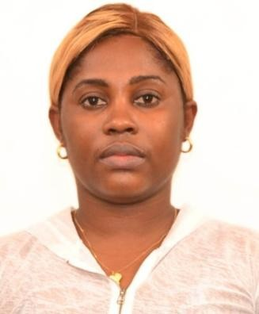

ANTHONIA

Address: SHARJAH, UAE

Objective:
To find long term opportunities with a company where I can share my
Experience and Communicate with Customer’s, problem solving and guidelines in keeping Customer’s confidential details.

Skills:

- Experienced working with teams
- Excellent communication skills
- Physically fit, Goal – oriented
- Highly organized, Punctual

Work Experience:

CUSTOMER SERVICE (2014-2018) DIAMOND BANK PLC - NIGERIA

Duties and Responsibilities:

- Attends to training of banking activities.
- Review all Files& Registers
- Directly attends to all Customer’s issues
- Issuing of ATM and Cheque books to customers
- Smile and be Polite to Customers complain

CUSTOMER SERVICE (2018-2019)
ACCESS BANK PLC - NIGERIA

Duties and Responsibilities

- Meet Customers’ expectations
- Listen to customer’s complain
- Highly organized, Punctual
- Physically fit, Goal-Oriented

Education:
- SENIOR SECONDARY SCHOOL- NIGERIA (2007)
- NATIONAL DIPLOMA IN- BUSINESS STUDIES
- NATIONAL OPEN UNIVERSITY, BSC -COOPERATIVE MANAGEMENT- 2018

Personal information:

- Single
- DOB : 05/07/1989
- Visa Status : Visit Visa
- Hobbies include reading, fitness, music

Personal Contact : anthonia-396999@2freemail.com
Reference : Mr. Anup P Bhatia, HR Consultant, Gulfjobseeker.com 0504753686

ANTHONIA

