Shafeeque
POSITION FOR ELECTRONICS & COMMUNICATION ENGINEER

ACADEMIC QUALIFICATIONS
B.Tech(Electronics & communication)
(MG University, India)

PROFESSIONALEXPERIENCE

- 2019- 2020- Airtel
(Sales & Technical Support Engineer)

- 2016- 2018 – Eurotech
(Show room manager)

- 2014 - 2015 – Nayan communication
(V- SAT Engineer)

- 2014 - BSNL
(Engineer- Signal Control)

JOB PROFILE
- Project management, supervising and coordinating the work
- Assist senior engineer in commissioning activities
- Maintains relationship with clients by providing support information & guidance.

KEY SKILLS& STRENGTH
- Ability to work in a fast-paced changing environment
- Self-motivated& committed to excellence
- Punctual & systematic
- Team player with the ability to lead
- Good communication & interpersonal skill
- Eagerness and ability to learn new things quickly.
- Engaging & easily moving along with people

Declaration
I here by declare that all the statement above mentioned are true and correct to the best of my knowledge & belief.

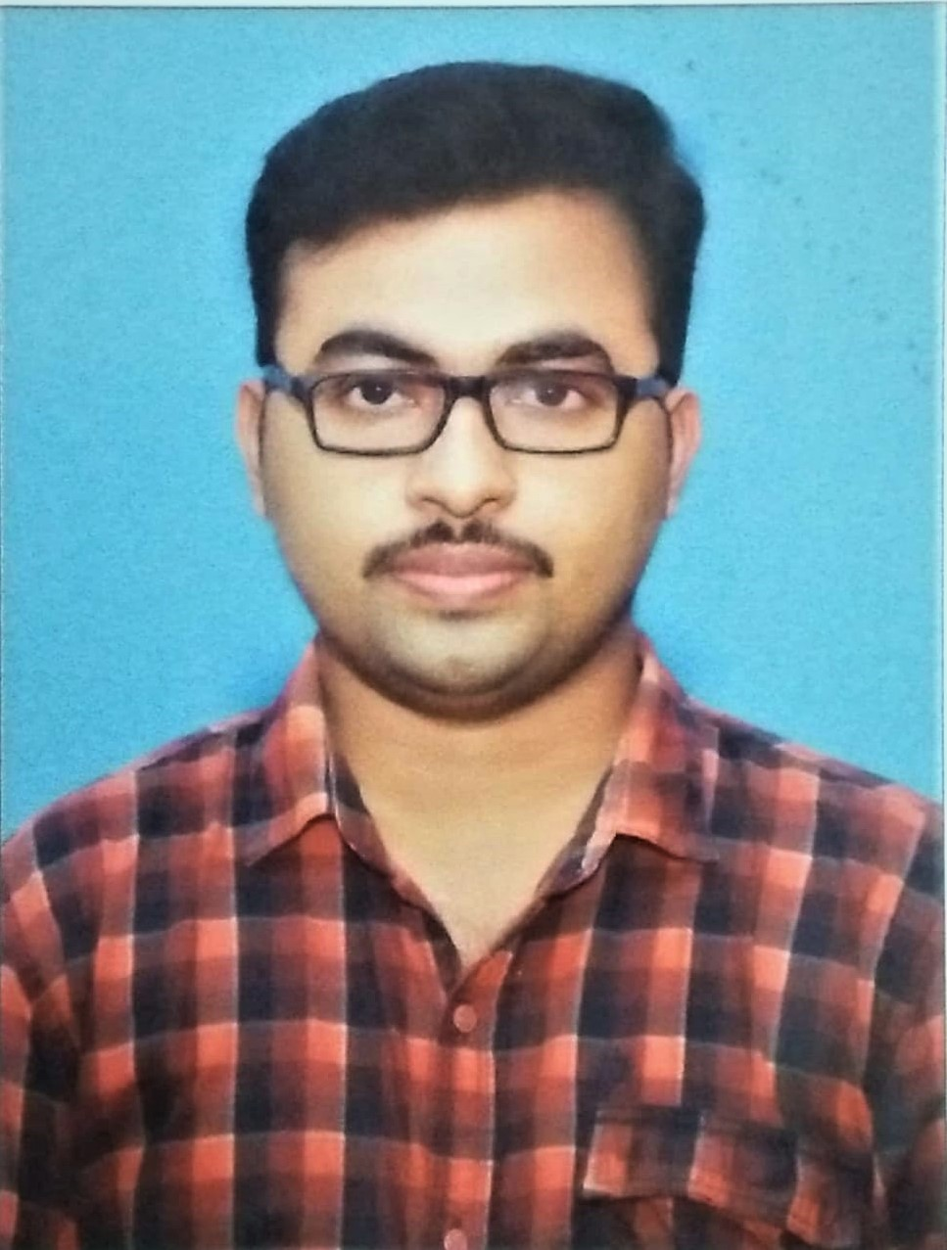

PERSONAL DETAILS

Nationality: INDIAN
Date of Birth: 01/July/1992
Marital Status: Married.

PASSPORT DETAILS

Valid till: 09/01/2029

Visa Status: Visit visa
Valid till: 16/05/2020

LANGUAGES

- English: fluent
- Arabic:read & write
- Malayalam: Fluent

PERSONAL SKILLS

- Focused
- Ability to empower
- Innovative
- Quick learning

COMPUTER SKILLS

- Software: MS Office

DRIVING LICENSE

- Valid Indian driving license

HOBBIES & OTHER INTEREST

- Listening Music
- Travelling
- Playing Foot ball & cricket

CONTACT DETAILS

Personal Contact:
Shafeeque-397009@2freemail.com

Reference: Mr. Anup P Bhatia, HR Consultant, Gulfjobseeker.com 0504753686

