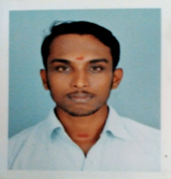

JISHNU
Email : jishnu-397023@gulfjobseeker.com
Date of Birth : 28th December 1993
Experience
1) Designation : Jr. Site Engineer
Period: September 04th 2017 to (continuing)
2) Name of company : BismiAppliances&Pvt ltd,Thrissur, Kerala
Designation : Jr. Site Engineer
Period: March 2015 to August 2017
3) Name of company : Ab-Tek Constructions, Kakkanadu, Kerala
Designation : Site Supervisor
Period : February 2013 to March 2015

Duties & Responsibility
- Checking quality of work
- Checking contractor’s bills
- Work completion in target date
Academic Profile
- Civil Engineering from Govt. Industrial training institute,Mala with First class [65%] .
- Class XII Passed in first class [65%] from Co-operative College, Kodungaloor in March, 2010.
Languages Known

- Malayalam, Hindi, English, Tamil

Technical Profile/Computer Skills

- Packages : MS Office, MS Word, MS Excel

^{Declaration:}

I hereby declare that all the information given above are true and correct with the best of my knowledge and I bear the responsibility of the above-mentioned particulars.

^{Place:} ^{yours sincerely}
^{Date: (JISHNU)}

