IRFAN
MECHANICAL ENGINEER
Experienced, organized Mechanical Engineer with a background in project management. In possession of strong communication and leadership skills due to professional experience as a worker and oﬃcer.

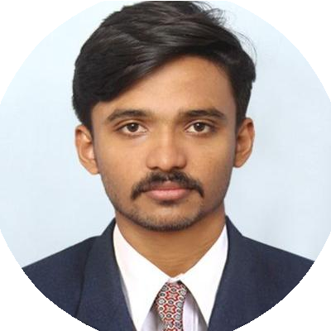

WORK EXPERIENCE

Operations Oﬃcer

High Range Coffee Curing Pvt Ltd
11/2017 – 12/2019
Achievements/Tasks
Spearheaded project designing mechanical systems for new high scale production factory. Implemented Solid Edge for computer aided designs.
Coordinated employees and resources throughout the entire product cycle. Organized the machine operation in proper time without any delay.
Investigate problems, analyze root causes and derive resolutions. Optimized business processes to foster operational eﬃciency.

COORG

Established positive and effective communication among unit staff and organization leadership, reducing misunderstandings and late tasks.
Established eﬃcient workﬂow processes, monitored daily productivity and implemented modiﬁcations to improve overall effectiveness of personnel and activities.
Improved customer satisfaction scores through application of superior conﬂict resolution and problem-solving skills. Kept physical ﬁles and digitized records organized for easy updating and retrieval by authorized team members.

Shutdown Work Trainee

AVT Naturals
08/2017 – 10/2017
Achievements/Tasks
Maintenance & repair of compound gears, shafts. Maintenance & repair of ﬂanges, FBD. Maintenance of Pre Treatment plant machineries.

Aluva, Ernakulam

GENERAL SKILLS
Time Management
Project Management
Teamwork
Communication
Leadership
Problem solving

EDUCATION

B.TECH in Mechanical Engineering

MAHATMA GANDHI UNIVERSITY
05/2013 – 05/2017
Courses
DYNAMICS OF MACHINERY MECHANICS OF MACHINES
GRAPHICS FLUID DYNAMICS

Kottayam

Higher Secondary in Computer Science

DR ZHM BHARATIYA VIDYA VIHAR ( CBSE )
2011 – 2013

Changanacherry, Kerala

PROJECT AND INTERNSHIP

Electromagnetic Reciprocating Engine
Developed a system that converts electric energy into reciprocating motion by using electromagnetic effect. Concept of zero point fuel consumption.
The general property of magnet, attraction and repulsion forces is converted into mechanical energy.
The useful output is rotating motion and the application is based on electromagnetic engine which varies from different ﬁeld.

Internship at Josh Designs Ltd, authorized service station of Force Automobiles
Maintenance in Engine Room, Traveller Alteration Section, Clutch and Pump Section. Repair of engine inlet valve, cylinder and piston parts.
Maintenance of speedometer and clutch parts.

INTERESTS
Designing Mechanics Automobile Heat Transfer

PERSONAL PROFILE

Age : 24 Nationality : Indian
Marital Status : Single

Visa : Visit, Valid till 25 April 2020

Passport Validity : ( Valid Till 07/03/2028 )

LANGUAGES

ENGLISH
Full Professional Proﬁciency
MALAYALAM
Native or Bilingual Proﬁciency
HINDI
Professional Working Proﬁciency

Personal Contact : irfan-397084@2freemail.com

Reference : Mr. Anup P Bhatia, HR Consultant, Gulfjobseeker.com 0504753686

