Name: JONATH
M.Com (Finance and control)
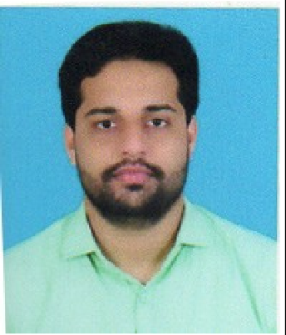
Objective

To work for a professional organization which offers challenging opportunities, an excellent cooperative working environment, to utilize my professional and technical knowledge, which enables me to improve my abilities and improve the organization plans and work procedures.
Academic Qualification
Course | Institution | University/Board | Year of Passing
PG (H.D.C.&B.M) | Co-Operative Training College | State Co-Operative Union Kerala | 2019
PG (M.Com F&C) | CMS College of Science and Commerce. | Bharatiyar University | 2016
UG (B.com) | Don Bosco Arts and  Science college Angadikadavu. | Kannur university | 2014
PUC | Higher Secondary School | Kerala HSE board | 2010
SSLC | High School | Kerala HSE board | 2008

Work Experience
- Being part of theB.G BALIGA & Co, a reputed Chartered Accountants Senior firm in Mumbai, Bengalur Working as Account Assistant in Mumbai.(1st August 2016 to 19thDecember 2017)
- Being part of the MALABAR GROUPS worker as Junior Accountant in Kozhikode and Hyderabad (1st April 2018To 30th September 2018).
- Currently working in Khalil Turbo as Accountant at Qatar.
Work Profile
- Office Administration, maintain client relation managing and training clerical/ junior level staff.1
- Maintaining petty cash book authorize payments done by cash and Bank.
- Making entries under appropriate account Head of the book.
- Done Statutory Audit of two Crane Mfg.Co. Pharmaceutical Co. etc and internal Audit.
- Submit monthly reports regarding the expenses and cashbook balances.
- Receive sales and purchase reports and note the amount of sales / purchase returns by recording corresponding entries. Also compute the amount of goods in stock and add it to the assets accounts.
- Practical knowledge from daily bookkeepingto individual and commercial Auditing.
- Bank reconciliation.
- Assist in preparing daily sales report.
- Preparation of sales comparison sheet.
- Assist in preparation of shop position sheet.
- Proper filing and maintenance of documents.
- Assist in tallying cash and Gold weight.
- Perform other duties assigned by management from time to time.
Project Accomplished and Training
- M.Com (FC): Institutional Training at Periya Service Cooperative Bank for one month.
- M.Com(FC) : Financial Analysis of Banks ; With Special Reference to four leading Public And Private Sector Bank in India.
- H.D.C&B.M : Practical Training with department of co-operation of 12 days.
- H.D.C&B.M : Project report on a study on overdue analysis of Pallikkare Co-operative bank ltd.no.l.68
Technical Proficiency
- Proficient in TALLY. ERP 9
- Proficient in MS office
- Proficient in Web tools
Strengths
- Hard working & Confident
- Communication Skill
- Good Team Player
- Interpersonal skill
- Positive attitude

u

Arts And Sports
Arts
- Leader of College National Service Scheme (2nd year) Don Bosco Arts and Science College, Iritty, Under Kannur University.
- Associate Finance Secretary of Department of Commerce.
- Worked as an active member in National Service Scheme (2 year).
- Participated in different intercollege management fest.

SPORTS
- Member of Don Bosco Basket Ball Team.
- Participated different inter college Basket Ball match.
- Playing Volley Ball.
Personal Profile.

Name : Jonath
Date of Birth : 19-09-1991
Sex : Male
Nationality : Indian Material Status : Single
Language Known : Malayalam, English, Tamil, Hindi Hobbies : Playing Basket Ball, Cooking.
Personal Contact : Jonath-397085@2freemail.com
Reference : Mr. Anup P Bhatia, HR Consultant, Gulfjobseeker.com 0504973598
Declaration

I hereby declare that the above information is correct up to my knowledge and I bear the responsibility for the correctness of the same.

PLACE:
DATE: JONATH

