**CURRICULUM VITAE**

**JACOB**

**[Email:](mailto:odianco@yahoo.co.uk)** [Jacob-397177@gulfjobseeker.com](mailto:Jacob-397177@gulfjobseeker.com)

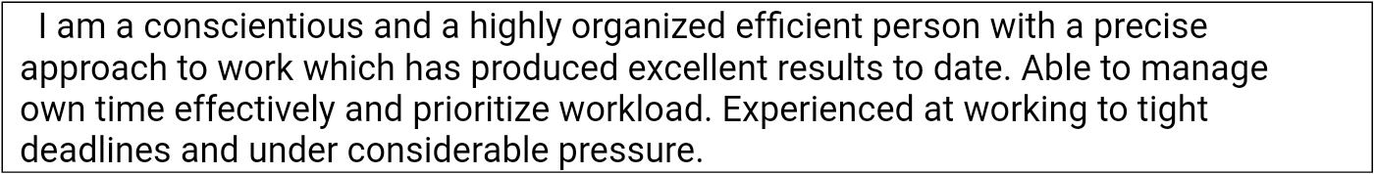

**APPLYING FOR S.T.P OPERATOR**

**PERSONAL DATA**

Nationality: Nigerian

Sex : M

Age : 30

Marital Status : Married

Language : English

Visa Status : Employment Visa

# WORK EXPERIENCE/ CURRENTLY

DESIGNATION: S. T. P OPERATOR.

DURATION : 2 YEARS.

LOCATION : ABU DHABI.

**DUTIES AND RESPONSIBILITIES**

*To add chemicals, such as ammonia or chlorine, to disinfect water or other liquids

*Inspect equipment on a regular basis

*Monitor operating conditions, meters, and gauges

*Collect and test water and sewage samples

*Record meter and gauge readings and operational data

*Operate equipment to purify and clarify water or to process or dispose of sewage

*Clean and maintain equipment, tanks, filter beds, and other work areas

*Follow U. A. E. Environmental Protection Agency regulations

*Ensure safety standards are met

**Training/workshop attended.**

*H2S Training – 2019 Abudhabi (ADNOC DRILLING)

*Basic Fire Fighting – 2019 Abudhabi (ADNOC DRILLING)

*Working at Height – 2019 Abudhabi (ADNOC DRILLING)

*Lifting/ Rigging/ Slingging - 2019(ADNOC DRILLING)

PERSONAL SKILLS

*HSE awareness

*Desire to succeed

*Winning work ethics

*Speak and write English

*Attention to details

*Trustworthy.

*Hardworking

# EDUCATION BACKGROUND

*Paramount Computer institute: Nigeria.

*High school education: Nigeria.

*Institute of waste management: Nigeria

# DECLARATION

I hereby declare that all the informations furnished above are true and correct to the best of my knowledge and belief**.**