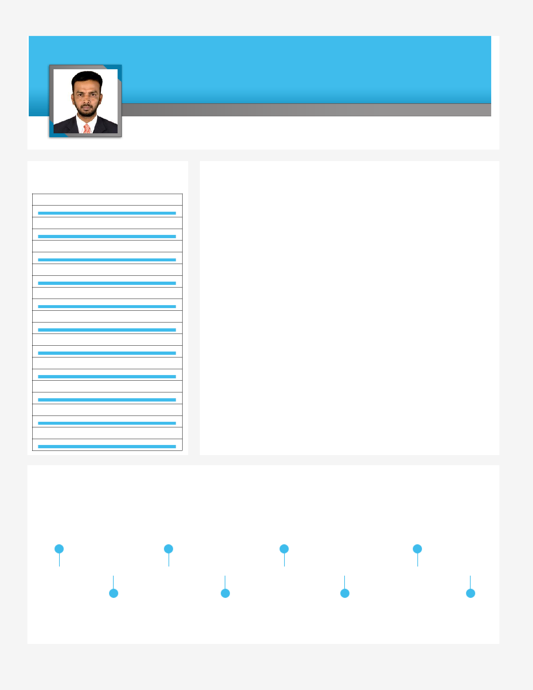
SHUJAUR

Targeting challenging assignments with an organization of high repute

Finance & Accounts Audits & Taxation Team Management

shujaur-397239@gulfjobseeker.com

Key Skills

Finance & Accounts

Budgeting & Cost Control,

MIS Reporting

Audits & Taxation

VAT, Excise & Customs

Statutory Compliance

Accounts Receivable / Payable

Payroll Process

Process Improvement

Team Building & Leadership

Liaison & Coordination

Profile Summary

- An accomplished professional with over 18 years of experience in managing finance & accounts activities including financial reporting and finalisation of accounts, taxation, budgeting and financial projections, statutory compliance, accounting & tax matters, Customs duty & Excise TAX.

- Expertise in formulating budgets, implementing systems / procedures, conducting analysis, preparing key reports to exercise financial control & enhancing overall efficiency of the organization

- Proficiency in managing financial accounting, receivables & payables management, preparing ledger books, bank reconciliation statements and finalization of accounts

- Gained exposure in improving impact business growth & maximize profits through achievements in finance management, cost reductions and internal control & productivity improvements

- Expertise in generating reports to provide feedback to top management on financial performance such as analysis of profit, sales, costs, material consumption, inventory & overheads

- Implemented cash controls to monitor cash flow, resulting in improved cash utilization and interest spread

- An effective communicator with excellent interpersonal, analytical and leadership skills

Career Timeline

 | Althaf Associates, India |  |  |  |  | Amtex Infotech |  |  | First Choice House |  |  |  |  | Farida Tannery PLC,
 |  |  |  |  | Pvt.Ltd., India as |  |  |  |  |  |  |  |  |  | Ethiopia
 |  | Audit Assistant |  |  |  |  |  |  | L.L.C., Ajman, U.A.E.
 |  |  |  |  | Accounts -Officer |  |  |  |  |  |  |  |  |  | Senior Accountant
 |  |  |  |  |  |  |  |  | General Accountant
 |  | Aug’99-Mar’01 |  | Dec’01-Dec’06 |  | Dec’06-Aug’07 |  |  | Aug’07-Dec’08 |  | Dec’08-Apr’12 |  | Mar’13-Nov’13 |  | Nov’13 Nov’17 |  |  | Mar’18-Till date
 |  |  | Farida Shoes Pvt. |  |  |  |  |  | Farida Shoes Pvt.
 |  |  |  |  |  |  |  |  |  |  |  |  | Indchem Marketing
 |  |  |  | Ltd., India |  |  |  |  | Ltd., India |  |  |  | Corp., India
 |  |  |  | Team Leader |  |  |  |  | A.HOD |  | Accounts & Branch In-
 |  |  |  |  |  |  |  |  |  |  |  |  | charge |  |  | Senior Accountant

Education

B.Com. from Madras University

Other Course:
Data Preparation and Computer Software (DPCS) from Jamia Darussalam ITI

Notable Accomplishments Across The Career

- Ensured completion of statutory audits of Althaf Associate, Farida Shoes Pvt. Ltd., (India) & Farida Tannery
- PLC, (Ethiopia) as per local GAAP requirements and timely filing of Annual Returns in these countries
- Automated the preparation of reports using Tally ERP & MS-Excel

- Engaged in initial requirement gathering for the implementation of SAP and Tally ERP at Farida Shoes Pvt. Ltd.,
- Farida Tannery PLC; acted as key trainer for Tally ERP Inventory & Finance module
- Co-ordinating with IT for Finance/Accounts software development.
- Improved the timeliness of month-end financial reporting from approximately 4 to 2 days

- Developed rolling forecasts for cash flow, profit & loss projections for review by management; undertook
- risk and return analysis, sensitivity analysis for the short and long term
- Assisted in the development of annual and long-range plans that linked business strategies to operational
- plans and the expected range of financial results
- Monitored key performance indicators, operational performance indicators, strategic initiatives, risk
- scenarios and business plans for the Finance Department
- Stock Audit, Import & export documents and Import Voucher Reconciliation.

Work Experience

Mar’18-till date in Dubai, UAE as Senior Accountant
Role:

- Managing budgets, controlling cash flows and analysis the actual Monthly expenditures with the budgeted.

- Finalizing various accounts in coordination with internal & statutory auditors for conducting audits in compliance to the tax
- Monitoring Job status on daily basis.
- Preparing and submitting Monthly VAT without fail.

- Generating and presenting weekly and monthly management reports on cost and benefit analysis, productivity analysis.

- Preparing P&L, Balance Sheet, Cash & Fund flow, Budgets, finalization of Accounts and proper closing books of accounts.
- Developing and Managing Financial System/Modules
- Co-ordinating with IT for Finance/Accounts software development.
- Supervising Staff’s, Liaising with Managerial Staff and Other Colleagues.
- Payroll, WPS & Other Administration works.

Nov’13-Nov’17: Farida Tannery PLC, Ethiopia as Senior Accountant
Role:

- Checking & assessing the value drivers of business and developing analytics around key measurements to facilitate business decision-making

- Acquiring inputs from Finance Dept., analyzing financial results for identifying weaknesses and suggesting remedial measures to Business Unit Heads

- Formulating budgets and conducting variance analysis to determine difference between projected & actual results and implementing corrective actions

- Monitoring cash flow by taking adequate measures for optimum utilization of available funds; developing effective framework on the basis of tax assessment for acceptable levels of residual risk

- Attending & facilitating audits, evaluating internal control systems with a view to highlight shortcomings and implementing recommendations provided by auditors as per govt. rules & regulations

- Computing & arranging the timely deposit of taxes (Indirect, Direct, Income, Customs, VAT & Indirect) and filing PENSION returns as per statutory norms
- Preparing and submitting Monthly VAT, Pension, Withholding Tax filing.
- Preparing & Submitting Monthly or quarterly VAT Refund related documents to Ethiopian Customs.

- Generating and presenting weekly and monthly management reports on cost and benefit analysis, productivity analysis, inventory turnover analysis and cost variance analysis
- Preparing of Import & Export documents and follow up with clearing agents.

- Import Voucher Scheme Reconciliation documents and report preparation as per Ethiopian Customs requirement only yearly basis and problem solving.
- Monthly Physical Factory Cash Verification and processing & checking payroll register.
- Quarterly Physical stock verification all stores, (WIP, FG & Others)
- Knowledge of Company formation, Memorandum & Articles of association, Minutes of Meeting etc.,

Mar’13-Nov’13: Indchem Marketing Corporation, Ranipet, India as Accounts & Branch In-charge

Role:
Supported administration & debtors collection
Prepared various monthly & quarterly reports such as Profit & Loss, Balance Sheet, Fixed Assets Schedule, Operating Expenses Schedule, Customer wise Sales Report, Sundry Debtors Collection Report, Sundry Creditors Outstanding Reports, and so on

Provided & compiled data for auditing during finalization of accounts

Dec’08-Apr’12: First Choice House L.L.C., Ajman, U.A.E. as General Accountant
Role:

Managed a range of functions including:
- Maintaining and finalization accounts
- Preparing Profit & Loss, Balance Sheet, and so on; preparing MIS Reports
- Processing WPS Salary as per UAE Law, Monitoring Visa & Labour Card work, and so on

Aug’07-Dec’08: Farida Shoes Pvt. Ltd., Ambur, India as Associate Head Of Department

Role:
- Prepared monthly & quarterly reports such as Income & Expenditure Schedule, Balance Sheet, Fixed Assets

- Schedule, Operating Expenses Schedule, Revenue Analysis Reports, Customer wise Sales Report (Farida
- Shoes Group)
- Provided & compiled the data for auditing during finalization of Accounts
- Worked on:
- Sales Tax Assessment, VAT Refund, Other Indirect Tax Refund, Income Tax & Sales Tax Hearing|

Previous Experience

Dec’06-Aug’07: Amtex Infotech Pvt. Ltd., Chennai, India as Accounts - Officer

Dec’01-Dec’06: Farida Shoes Pvt. Ltd., Ambur, India as Team Leader

Aug’99-Mar’01: Althaf Associates, Chennai, India as Audit Assistant

IT Skills

Knowledge of MS Office, Tally ERP 9.0,Peachtree, Quick Books & Logistics Softwares Oracle & Other cloud based softwares.

Personal Details

Date of Birth: | 13th May 1980
Languages Known: | English, Tamil, Urdu, Arabic & Amharic
Visa Status : | Employment Visa

