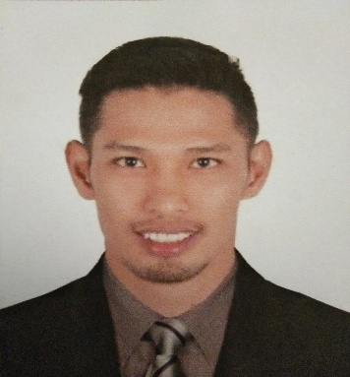
ENGR. JHONNEL
E-mail: jhonnel-397242@gulfjobseeker.com
Visa Status: Visit Visa

WORK EXPERIENCES

Mechanical Engineer
September 26, 2018 – January 08, 2020

RESPONSIBILITIES
- Client and site inspection surveying
- Mechanical& Electrical estimation
- Designing ( Auto Caddlayouting& modeling)
- Metal fabrication designing
- Project planning & management
- Minor structural designing
- Machine design (research & development)

Project Mechanical Engineer
Ralgo Industries Inc.
406 TandangSora Avenue, Quezon City
June 01, 2017 – September 15, 2018
HVAC Contructor

RESPONSIBILITIES
- Reviews plans & specification and other related documents prior to project implementation.
- Oversees progress of work, prepares manpower and construction schedule.
- Supervises preparation of shop drawing and as- built plans.
- Supervises manpower daily activities.
- Coordinates with different trades & attend coodination meetings.
- Performs materials take-off and cost estimates as needed on site.
- Preparation of progress / accomplishment report.
- Preparation of progress billing.
- Performs other jobs related to your duties as directed by the management.

PROJECT FINISH

AMAIA SKIES CUBAO TOWER 2
Cubao, Quezon City, Philippines
Commercial building (with 36th floor Condominium Building)
HVAC- Scope of works

FILINVEST MIMOSA CYBER ZONE BUILDING 1 & 2
Clark Development Center, Angeles City, Pampanga Philippines
Commercial Building ( with 5 Floors eachBPO Building )
HVAC –Scope of works

INSTALLATION&DESIGN OF DUST COLLECTOR SYSTEM
Ultra Insulated Panel
San Felix, Stotomas, Batangas Philippines

INSTALLATION& DESIGN OFCOMPRESSED DRY AIR SYSTEM
Planters, fertilizer company
Canlubang, Laguna Philippines

INSTALLATION& DESIGN OF GANTRY OF VIGAN HOPPER
Mariveles Grain Terminal
Mariveles, Bataan Philippines

EDUCATION

TERTIARY Bachelor of Science in Mechanical Engineering
Techological Institute of the Philippines
Casalst., Quiapo, Manila, philippines
June2007 – June 2016

Diploma in Computer Studies
System Technological Institute
A MabiniAve., Tanauan City, Batangas, Philippines
June 2004 –March 2006
SKILLS

- Proficient in operation and making plans in AutoCad ( 2D & 3D Modelling and Rendering )
- Generating Bill of Materials and related costings
- Designing metal works and Fabrication Drawings
- Project Management
- Utilize lifelong learning skills in pursuit of personal excellence & development in professional practice.
- Encoding and Presenting skills.
- Well versed with both Written & Oral English.
- Creative and Artistic.
- Goal Oriented and Trainable.

RESEARCH UNDERTAKEN

- Bataan 2020 manufacturer of fine class and quality paper, board and tissue in the Philippines. The company used boiler that produce steam used for the drying of the product and booster fan used to deliver need air for combustion and used to transfer the fuel (rice husk) to the boiler. The company suffered the total shut down of production because of misalignment of blade of the fan, and had no back-up booster fan that continues the production. My contibution to this project, I'm the one of the two member visited the plant to collect needed data, and had a part for designed back-up.

ACHIEVEMENT

- MECHANICAL ENGINEER BOARD LICENSURE EXAMINATION PASSER – MARCH 2017

