Sylwester

Dubai, UAE

Sylwester-397255@gulfjobseeker.com

More than 12 years of rich experience in managing the entire gamut of landscape management activities involving planning, maintaining, managing private residence and commercial building grounds as a Landscaper with an organization of repute.

LANDSCAPE FOREMAN | LANDSCAPE MANAGER | LANDSCAPER

Executive Profile

Progressive, decisive and innovative Landscape Worker, highly valued for expertise in interpreting the vision and strategy, and translating objectives into actionable plans.

Comprehensive business & technical skill set for handling assignments for the landscaping projects. Adept at rectifying designing and construction issues with the potential to result in a legacy of maintenance or aesthetic issues.

Possess outstanding physical stamina to handle all kinds of landscaping and groundskeeping work in both hot and cold weather as needed.

Recognized as a creative leader, combines excellent interpersonal and communication skills with proven expertise in the leadership, training, and development of cross-functional teams. Ability to obtain top performance from staff. Computer literate.

Key Impact Areas

Landscape

Management Project

management Creative

designing

Knowledge of various tree and plant

types Planning, Designing and

Installation Communication and

Interpersonal Skills Organizational

Skills

Resource Utilization and Management

Education & Credentials |  |  |  |  | Key Skills
 |  |  |  |  | CommunicatorCollaborator
2002
 |  |  |  |  | IntuitiveInnovator Analytical
Electronic Technician, Regionalne Centrum Edukacji
 |  |  |  |  | Motivator
Zawodowej w Lubartowie, 1 Maja 82, 21-100 Lubartów, Poland
 |  |  |  |  | TeamBuilder
Career Timeline
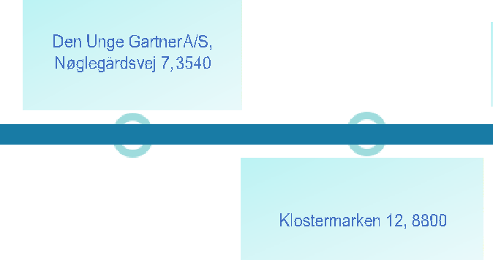 | Landscaper
 | Lynge
 | Jul 2006 - Dec |  | Jan 2012 - Jul | Aug 2015 -
2011 |  |  | 2015 | Present

Landscaper

HedeDanmark a/s,

Viborg

Professional Experience

Aug 2015 - Present: Company Owner in Denmark

Key Result Areas:

Key contributor in managing and planning the landscaping projects.
Fully accountable for landscaping and maintaining private residence and commercial building grounds. Having credential of operating all ground and gardening equipment safely and efficiently.
Leverage broad competencies in designing and installing garden walls.
Functional responsibilities include installation of rock gardens, building hardscapes, including stone and brick walkways and patios, retaining walls, and fences.
Interface and coordinate with clients to provide excellent and efficient customer service. Entrusted with the onus of keeping job sites safe and secure for employees and equipment. Apply skills in planting new trees, flowers, bushes, and grass according to specifications.
Tasked with installing rock gardens, ponds, and irrigation systems in accordance with client specifications.

Jan 2012 - Jul 2015: Landscaper, HedeDanmark A/S, Klostermarken 12, 8800 Viborg

Jul 2006 - Dec 2011: Den Unge Gartner A/S, Nøglegårdsvej 7, 3540 Lynge

Key Result Areas:

Provided oversight to identify and report design and construction issues with the potential to result in a legacy of maintenance or aesthetic issues and with a view to rectify, modify and resolve issues.
Imparted great contribution in acquiring information, plans, and resources to ensure a seamless and cost-efficient transition from construction to maintenance processes of the installed landscape.
Collaborated with contractor(s) to ensure all contractual obligations and associated Service Level Agreements were met. Ensured the quality and safety of contractual works as per community comfort and convenience.
Accountable to establish detailed work plans to meet project milestones and continually monitored progress. Assisted in the design, development, and tendering of the Landscape Maintenance Contract. Provided assistance in developing a contract consisting of site conditions, variables, installed landscape and its maintenance requirements and achieving a quality solution at the best possible price.
Rendered general support for the quality of the lake's environment to ensure a pleasant, safe, fit for purpose and sustainable water quality solution, including supporting controls on pollution.

Highlights:

Displayed credentials in landscape and grounds keeping

work. Knowledgeable in a variety of tree and plant types.

Received appreciation for operating small and large hand and motorized garden and landscaping tools.

Played a pivotal role in project planning, budgeting, and identification of resources needed for the successful execution and completion of the landscaping projects.
Demonstrated efficient and effective coordination, direct supervision of landscape works, lakes and their related services, including client services and support, in line with organizational objectives.

Courses:

Landscaping, Selandia - CEU, Jan 2015 – Feb 2015
Road Construction Safety, København Tekniske Skole, Feb 2014 – Feb 2014
Landscaping, Selandia - CEU, Nov 2011 – Nov 2011

Personal Details

Date of Birth: 18th Sept 1982

Nationality: Polish

Marital Status: Married

Languages Known: English, Danish & Polish

Driving License: B+E

Visa Status: Wife Visa

