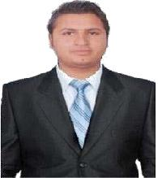
Kishor

Mechanical Engineer (M&P ENGINEER)

E-mail: kishor-397264@gulfjobseeker.com

Mechanical Engineer with 7 yrs.

experience in: PLUMBING & QA/QC ENGINEER in UAE.

Education:

Bachelor degree in Mechanical
Engineering. Driving license: have valid

driving license manual UAE , INDIA

Projects completed:

- Hydra tower (G+28) in Alreem island as a QA/QC engineer

- AJAYL INTERNATIONAL SCHOOL in Abu Dhabi as a Site Engineer ( plumbing& QA/QC )

- 33 + 10 luxury villas in Jumerah Golf Estate as a Project Engineer ( plumbing & QA/QC )

- G+4 Labour accommodation in DIP 2. As a Project Engineer ( hvac & plumbing )

- Offices & warehouse in DIC. As a Project Engineer ( hvac & plumbing & QA/QC)

- Fore point 4 star hotel (G+2P+12) in Ras Al Khaimah. As a MEP COORDINATOR and Plumbing Engineer.

- G+2P+12 residential buildings green phase 2 sobha hartland llc. (Sr. PLUMBING PROJECT ENGINEER)

G+2P+12 BUILDINGS SHOBHA HARTLAND GREEN PHASE -2

MARCH 2017 TO TILL DATE
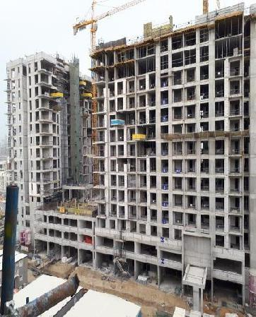

Duties and Responsibilities (Sr.Plumbing engineer )

Prepare and execution of detail layout plans for all drainage and water supply systems for all residential and official buildings.

Perform regular inspection on all equipment’s and materials and assist in fabrication of same if required.

Manage and perform tests on various materials and equipment’s and maintain knowledge on all product specifications and ensure adherence to all required standards.

Collaborate with various teams to design all architectural and electrical requirements for all plumbing projects.

Assist to allocate appropriate CAD design for all activities and ensure compliance to all client timeframe.

Evaluate all design drawings according to required quality regulations.

Monitor installation and perform tests on various water and sewage lines for all residential and commercial buildings.

Install various commission pumps.

Administer all plumbing work and provide certification to all contractor bills.

Perform regular inspection al materials and works for all plumbing activities.

Collaborate with all consultants and contractors for all plumbing associated work.

Follow up material availability on site .

Fore point 4 star hotel (G+2P+12) in Ras Al Khaimah. As a MEP COORDINATOR & Plumbing Engineer .

jan 2016-MARCH 2017

Short Description:

Responsibilities:

Review MEP contractor shop drawing prior to submittal for service

co-ordination and co-ordination with other construction elements. To advice on any impact on services caused by Architectural changes and
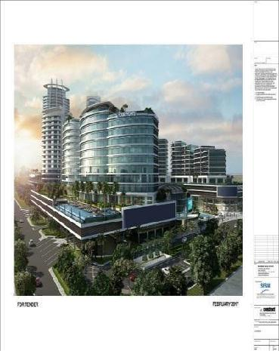
raise Query to MEP Manager Consultant. Review

material/equipment’s technical submittals from MEP contractor

for specification compliance. Produce equipment’s & builder-

work scope Schedule for all MEP equipment detailing construction and

maintenance requirement for equipment’s Review of method statements from MEP contractor with respect to installation works and logistics for equipment positioning. To liaise with MEP Manager on
matter seeking advice/requiring assistance. To assist internally QS

and Planning department for update MEP system

progress. Construction Phase: Ensuring that services provisions
clearance is provided in time for structure. To provide technical

advice to construction team. To oversee MEP service installation

under civil contractor scope of works. Close inspection for
MEP contractor installation works. Carry out site walks and
inspection for service installation, identifying poor quality elements and
advise construction team and MEP Manager. Carry out
inspection for MEP Contractor material along with QA/QC and
Consultant. Ensure that MEP site instruction/NCR are closed

out. To inspect concealed MEP service installation prior to closure of

void /riser etc in conjunction with QA/QC and obtaining consultant sign off. Ensure that Company HSE policies are implemented at site in coordination with HSE department.

G+4 BUILDING Labor Camp in Dubai Industrial city(DIP) (M&P project Engineer)

 |  |  | Short dicription
feb-2015 to may 2016 |  | Contract basis :
 |  | 1. full m & p work up to handing over.
 |  | 2. | full paper work follow up with client, consultant, authorities.
 |  | 3. | full material follow up.
 |  | 4. | full site coordination’s and daily base production reports.
 |  | Client: AL RAKHA GENERAL CONTRACTING LLC.
 |  | Consultant: PARADISE HOME CONSULTANCY.
 |  | Duration of Project: 1.5 Years. With ALRAKHA CONTRACTING
 |  | LLC. DUBAI
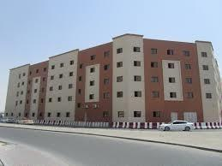

Short Description: DEC 2014-JAN 2016

ALRAKHA CONTRACTING LLC.

DAMAC AKOYA Villas

Location: Dubai Investment Park, Dubai, UAE
&
PRIVATE LUXURY VILLAS

33 VILLAS WITH DAMAC in

JGE

1.FULL Plumbing & hvac WORK UP TO HANDING OVER.

2.One year maintenance as per agreement.

Responsibilities:
Handle all paper work example:

Dealing with clients.

Dealing with authorities

Material supplier finalization.
Material approval from consultant.

MEP coordination

All site QA/QC work.

Consultant: ECC International

Duration of Project: 2 Years. WITH ALRAKHA CONTRACTING LLC. DUBAI (JGE)

10 PRIVATE LUXURY VILLAS

Short Description:

Consultant: PARADISE
CONSULTANCY Consultant:

DESIGN & HOUSE
CONSULANCY
Duration of Project: 2 Years WITH ALRAKHA CONTRACTING LLC. DUBAI (JGE)
Responsibilities: FIREFIGHTINGS, PLUMBING, HVAC

24TH FEB 2014 TO 30TH | AL RKHA GENRAL
SEPTEMBER | CONTRACTING LLC.
2015 | AJAYL INTERNATIONAL
 | SCHOOL
 | Location: | ABUDHABI (UAE)

PLUMBING ENGINEER

- Working closely with other discipline engineers, architects, designers and project managers as a key team player within an integrated multi-disciplinary project delivery team

- Communicating effectively with clients and internal team members in the design and specification development of plumbing building systems

- Communicating effectively with clients and internal team members in the design and specification development of building plumbing systems

- Perform building plumbing design and prepare construction documents for various commercial buildings. Systems include water, sewer, storm, compressed air, natural gas and fuel oil

- Contributing significantly to the successful design, production, coordination and management of projects

- Prepare fire protection system performance specifications
- Perform existing building analysis and condition assessments

March 2013 to April 2014
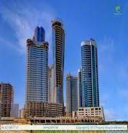

Short Description: Responsibilities: (QA/QC ENGINEER )

Short Description: -Perform specialist QA/QC techniques on critical structures and processes.

Prepare all necessary documents and attachments for the inspection and testing requirement.

Review the mechanical/electrical works check list, as built drawing and related quality control documents for final drossier.

Site inspection and co-ordinate to construction to implement the work completed in complies with code in accordance with specification. Coordinate inspections with Consultant / Client and to communicate with project team

Coordinate with client for inspection activities issued RFI (Request for inspection) for witness/hold point etc.

Report deviations from approved plans and specifications

Review all materials received on the site, inspecting them, ensuring they are as per approval.

Conduct testing within the required specification and to monitor frequency of testing.

Attend and participate in QA/QC meetings.

Proactively supervise the closure of NCRs, suggesting innovative ideas for improvement.

Liaise with the construction execution team management resolving problems quickly and efficiently.

Overall quality supervision for MEP works.

At site inspection time, follow safety rules & regulation at different hazards area

Comply, implement and participate in the improvement of established ISO QMS & EHSMS procedures/ documentations and maintain recordskeeping.

Ensuring that construction, installation, and operational testing conform to functional specifications and customer requirements.

Supporting and promoting all QHSE policies and procedures implemented by the company.

Preparing PQP, ITP, and other QA/QC documents that may be requested by Project Manager.

Reviewing material submittal and its compliance statement before forwarding to consultant’s approval.

Reviewing shop drawings before submission to consultant* Preparing of O & M Manuals in coordination with site management team.

Inspecting sites daily with consultants.

Maintaining a log and visiting store with consultant for permanent material inspection.

Coordinating for internal quality audit.

Closing the NCR's in coordination with Management Representative/Quality Manager.

Interacting with the project team in Quality requirements.

Completing the testing and commissioning tasks at project(s) as per project progress.

Maintaining all QA and QC documents legible.

Conducting the factory visit for testing of different equipment such as Stand by Generator, Fire Fighting Pumps, etc. before dispatching tosite.
Supervising work of quality service providers and inspectors.
Client: Musanada | 1 of 5
Consultant: ACE International

Duration of Project : 2 Years National Projects & Construction, Abu Dhabi, UAE

Personal Strength:

Can-do ability

Hard working, punctual, responsible and honest.

Personal Attributes:

Good analytical skills with problem solving capabilities.

Sincere and Commitment to excel in a given field.

Ability to deal with people diplomatically, Willingness to learn.

Calm, Confident and ready to face challenges.

Ability to Work Under pressure.

Vernacular Skill:

English, Urdu, Hindi, Arabic

 |  | PERSONAL DETAIL
Name | : | KISHOR
Date of Birth | : | 05-09-1987
Gender | : | Male
Marital Status | : | MARRIED
Nationality | : | India
Passport | : | Valid till 2021
Notice Period | : | IMMIDIATE JOINING.

Declaration:

I hereby declare that the information furnished above is true to the best of my

knowledge. Place:

DUBAI, UAE

Date:

KISHOR

