sagar-397268@gulfjobseeker.com

EXPERTISE

Customer Relations

Well trained and specialized in customer handling and client satisfaction.

Adobe Suite

Appreciable working knowledge of the major products offered by Adobe to enhance and drive creative forces.

MS Office

Using tools given by MS Office to recognize and drive the product in the market.

SKILLS

- Social Media Trends

- Keyword Research & Mapping

- Online Brand Identity
- Organic Search
- SEO & SEM
- Content Marketing
- HTML5
- Java
- C++
- DBMS
- Communication Skills
- Fast and Accurate Typing

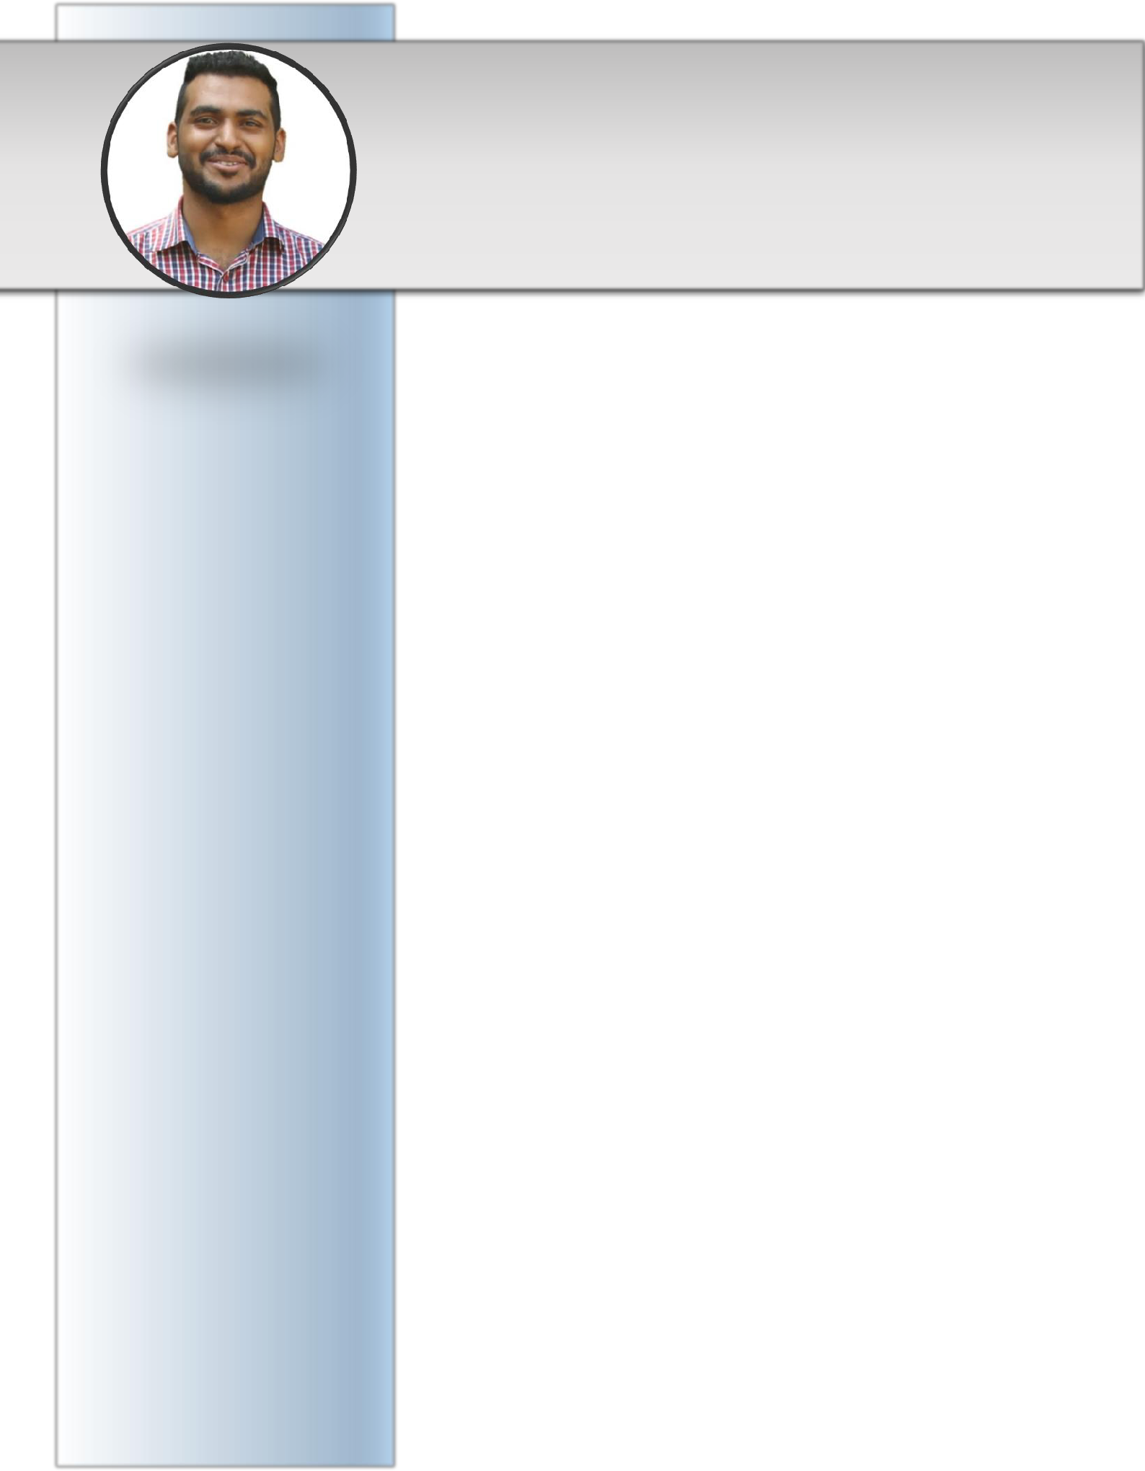
SAGAR

PROFILE

A creative Digital Marketing Manager; result oriented with a proven record of driving revenue gains. Well equipped with brand awareness, understanding of social media, customer engagement, and community building strategies. A firm believer in technology and stays updated on an everyday basis. Outstanding understanding of online marketing along with offline marketing strategies. Also, have a strong hold over presentation, interpersonal and communication skills.

Highlights Include:

- Led projects with budgets of over $25,000.

- Built and managed talented & productive team of up to 25 which had multi-functional purposes.

- Boosted lead generation for last employer by over 170%, primarily through social media followed by creative offline marketing.

- Over watched customer service to boost customer satisfaction and linked it with marketing to produce outstanding customer retention.

EXPERIENCE

Digital Marketing Manager
Bangalore, India

September 2017 – February 2020

Highlights Include:

- Build an efficient and effective team.
- Upgrading the brand image of the company.

- Pricing strategy development, testing their impact and final results analyses along with adjustment implementation.

- Affecting company culture via presentations and consultation to become more data-driven.

- Managing e-commerce promotions project.

- Conducting research and analyzing data to identify and define audiences.

- Writing and proof reading creative copy.
- Organizing events and product exhibitions.

- Establishing relationship with influencers and interrelated clients to collaborate and enhance brand exposure.

INTERESTS

Toastmaster

Participates in meetings to enhance communication and presentation skills.

Data Analysis

Learning on Udemy different courses to help better comprehend the market.

Reading

Fiction/Non-Fiction, reading
has been a staple of my life.

Football

Watching and playing the game allows me to learn things in the most fun manner possible. Truly passionate about the sport. Former captain of the school and college team.

LANGUAGES

- English - Proficient
- Malayalam - Proficient
- Hindi - Proficient
- Kannada - Intermediate

PERSONAL DETAILS

Nationality: Indian
DOB: 04th Dec 1992
Gender: Male
Marital Status: Single
Religion: Islam
Place of Birth: Riyadh, K.S.A.

Marketing Executive

GoldenGalaxy Inc. | Thrissur, Kerala, India June 2015 – July 2017

Highlights Include:

- Tracking changes in consumer engagement following the roll-out of each marketing campaign.

- Compiling reports detailing the effects exerted by each campaign, and sharing these with clients.

- Travelling across India to find potential clients and understanding the market trends.

- Ensuring adherence to clients' specifications.
- Making sure that campaigns run within the budget, on time.

- Responsible for development of print assets, including point of sale materials, graphics projects and advertising.

- Coordinated conferences and trade show presence, as a member of the marketing team.

PROJECTS:

- “Percuro” Pharma Website:

Created a website for B2B purpose which was to help the retailers keep track of the stock they have along with placing an order from the wholesaler the required products through the website. Provided single platform for both wholesaler and retailer. This Database would further help both the parties to understand the market. The site was created using MySQL Workbench, XAMPP and HTML5 for the back end and front end respectively.

- FPS Game:

Created a First-Person Shooter Game named “Teach Me” developed using Unity. The objective was for the player to shoot down the enemies (zombies) within a fixed amount of time. The level of difficulties increase as the player wins each round. The game also had narrative events and points of interest.

EDUCATION:

- Bachelor’s Degree on Computer Application - 2015 ISME, Bangalore, India – IADL

- +2 / Higher Secondary – 2012
Paatashaala, Bangalore, India – NIOS – Commerce

DECLARATION:

I, Sagar, hereby declare that the above cited information are factual and correct to the best of my knowledge and belief.

