KUNAL

MAIL: kunal-397328@gulfjobseeker.com

PROFILE SUMMARY

CFA from ICFAI Tripura University qualified with 11 years of diverse work experience. Handled self-created business portfolio of HNI clients.

Providing support for self-trading clients, Introducing Brokers and Money Managers.

Meeting clients, conducting seminars and educating them about risk management and profit maximization in margin trading
Maintaining stocks, daily sales report, stock transfers in and out, ledger, pricing and billing. Meeting monthly, quarterly or annual sales goal, depending on the company’s targets.

Preparation of dynamic Financial Models – (Income Statement > Cash Flow> Balance sheet> Depreciation) and (Discounted Cash Flow & Merger Model)
Performed Independent Valuations on companies of various sector. Creating Invoices, Revenue accruals and Contract management.

Client Servicing

Being solely responsible for the revenue side of the P&L for the projects undertaken. Ensuring timely closing of the invoices on a monthly basis within the contractual client
deadlines.

Ensuring DSO (Daily Sales Outstanding) target is met.

Ensuring the compliance of the processed invoices with the respective contracts and SOWs. Team Handling

CURRENT JOB ROLE

Relationship Manager Jan 2019 – Sep 2019

Handled a self-created portfolio of HNI clients who trades in Forex, Commodities, Bullion, Indices and crypto currencies worldwide.

Sales & Client Servicing:

Network and target HNI for business prospects.

Analyzing client's profile by helping them select the appropriate investment portfolio. Profile Summary
Following financial markets, implementing various trading strategies by combining technical and fundamental analysis.

Maintain the business portfolio risk profile within agreed parameters at all times, including monitoring/reporting of irregularities and customer KYC, AML etc.
Providing support for self-trading clients, Introducing Brokers and Money Managers.

Meeting clients, conducting seminars and educating them about risk management and profit maximization in margin trading.

Sourcing new leads, making contact, onboarding them and forging profitable ongoing relationships.
Analyzing sales report and company goals to develop new strategies in collaboration with the Sales Manager.
Keeping an eye on the frequent changes concerning the area of work, hours of operation, spread changes, holidays etc.

Making MIS reports and sending to the clients depending on their business products.

WORK SUMMARY
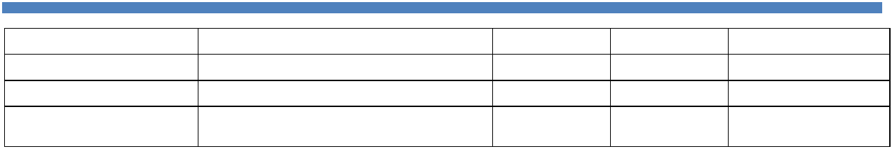

Organization | Designation | Start | End | Location
Rivoli Groups | Associate | Jan – 2015 | Dec – 2018 | Dubai
SMJ Capital Partners | Financial Analyst | Oct –2013 | Oct – 2014 | New Delhi
Convergys India | Finance Associate –Team Leader | Nov-2007 | Aug- 2013 | Gurgaon – India

EDUCATION SUMMARY
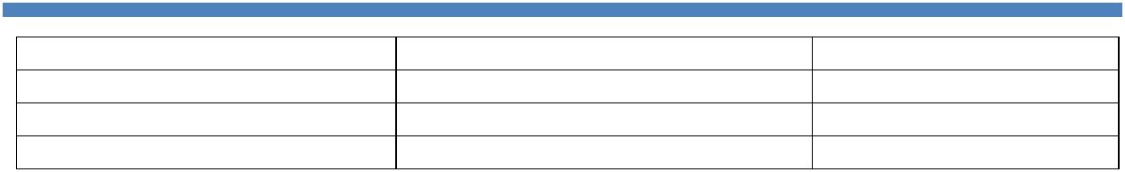

Degree | University | Completed Year
CFA – ICFAI | Tripura University – India | 2014
Investment Banking Certification | ARC School of Finance – New Delhi | 2013
Bachelor of Accounting | Patna University – India | 2007

PERSONAL DETAILS

Nationality: Indian

Date of Birth: 14th Nov 1987

Marital Status: Single

Languages: Hindi & English

Driving License: India & UAE

