SAIYAD

MIS executive & Sales Coordinator / Office Assistant /Cashier
D.O.B. | : | 27th -June-1992
Nationality | : | India
Email Id | : | Saiyad-397353@gulfjobseeker.com
Visa Status | : | On visit visa
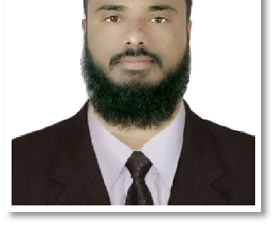

Profile

An MIS Executive & sales coordinator – or Management Information System Executive – is responsible for planning, coordinating and directing all computer-related activities within an organization. They help determine the company's information technology goals, and are responsible for implementing computer systems to meet those goals.

WORK EXPERIENCE (7 years +)

1.

DESIGNATION: - MIS EXECUTIVE – SALES COORDINATOR (DEC-2015 TO OCT-2019)
Report To Unit Head

Working in SAP & MS Excel, PowerPoint
Make a sales report everyday and send each team member

Communicated between Sales Team & Unit head departments provide support for sales activities Responsible for creating MIS & Data Analysis as require managements
Data entry of competitor NEWS papers.

Generating CCR report for sales team as per requirement. Planning and Tracking Team Activities and Deliverables
Make a presentation for Unit head every month for town hall meeting

- RESTAURANT

DESIGNATION: - CASHIER (EVENING SESSION) (JUNE-2018 TO NOV-2019)

Report To Restaurant Owner

Bill Entry in Restaurant Software Take and fill orders

Assisting the cashier in generation of the daily cash reports

Assisted with clean-up ,Maintaining detailed records of served orders and collected cash Manage large sums of money daily

3. VASAIWALA INDUSTRIAL TRANING CENTER

DESIGNATION: ADMIN ASSISTANT / COMPUTER INSTRUCTOR (2010 TO OCT-2015)

Report To Principal: Mr. Tofique Bodava

Conduct clerical duties, including filing, answering phone calls, responding to emails and preparing documents
Control Student Documents & Also Staff / Teacher Attendance Strategy planning & administration
Front Desk Operations

Computer Teacher from the period of oct-10 to aug-15

Actively involved in supervising & managing operation planning & development and directing the day to day academic & associated operation of the ITI.

Education

BACHELOR OF ART - Social sci. Complete BA in Bhavnagar university passed In2014

O Level- Diploma - Foundation in diploma course in DOEACC society pass with B grade

C.O.P.A - Computer Operator cum programming assistant– pass in 2010 with 69 %

HSC

SSC

- Commerce Stream (Higher Secondary) Pass in 2009 with 64% - (Matriculation) Pass in 2007 with 59%

Proficiency

 | SAP |  | Office Clerical
 | MS office |  | DTP
 | Advance Excel |  | Tally
 | Sales coordination | Basic hardware problem solving
 | Email coordination | OS & Software installation

Thanks,

Saiyad

