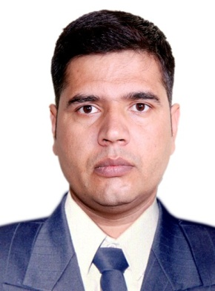

**Profile:**

I am Sunil is an accomplished Back Office Executive with 9 years of experience as a Corporate Employee. Who has proven success in organizing tasks.

**Career Objective:**

I intend to work to the best of my abilities in the professional and challenging environment and to utilize my knowledge and experience for the betterment of Company and myself.

**Education:**

* **Bachelor of Art (B.A)** - C.C.S University Meerut, UP, India

**Work Experience:**

* Wipro Technologies India for Vodafone Process as a **Administrator** from August 2013 to November 2019.
* Zensar Technology India as a **Coordinator** in HSBC Process from Feb 2012 to June 2013.
* Tech Mahindra India as a **Senior Associate** in TTSL Process Telecom from Nov 2009 to Jan 2011.

**Role and Responsibilities:**

* Part of Automation Team as a process SME
* Created Key Stroke level documents for the Robotics.
* Created Test Cases for various scenarios that need to be coded in the Robots.
* Checking all the application Web base, Siebel Base &DOS Base
* Working in Order Management Queue and handled multiple queues like Cancellation, New and MOD.
* Placing Broadband orders and to ensure timely follow up and closure.
* Preparing daily reports and to publish to all stake holders.
* Quality audits in the absence of SME / Team leader.
* Replying to client emails, queries and escalations effectively.
* Attended client calls in regards to operation challenges.
* Worked with Credit Card division.
* Documentation handling and validation.
* Civil Report verifying.
* Customer interaction in case of incorrect/incomplete documents.
* Customer Service Representative, handling inbound calls for resolution on disputes and services.

**SUNIL**

**Back office Executive**

Date of Birth : 1-Sep-1987

Email : [sunil-397354@gulfjobseeker.com](mailto:sunil-397354@gulfjobseeker.com)

Visa Type : Visit Visa

Nationality : Indian

**THANKING YOU,**

**Yours Sincerely,**

**Sunil**

**Additional Skills:**

* Knowledge of MS Office.
* Router installation and Troubleshot.
* Creating test cases for the Robotic Process Automation.
* Knowledge of Broadband and PSTN related issues

**Strengths:**

* Ability to work in a team and as a part of team.
* Good domain knowledge.
* Hard worker and quick learner.
* Open for any shift timings.
* Ability to work under pressure.
* Communication
* Prioritization and problem-solving
* Organization and planning
* Discretion
* Research and analysis
* Attention to detail
* Customer service
* Phone Etiquette

**Skills:**

**Languages:**

• English : Read, Write and speak.

• Hindi : Read, Write and speak.

• Marathi : Read and speak.