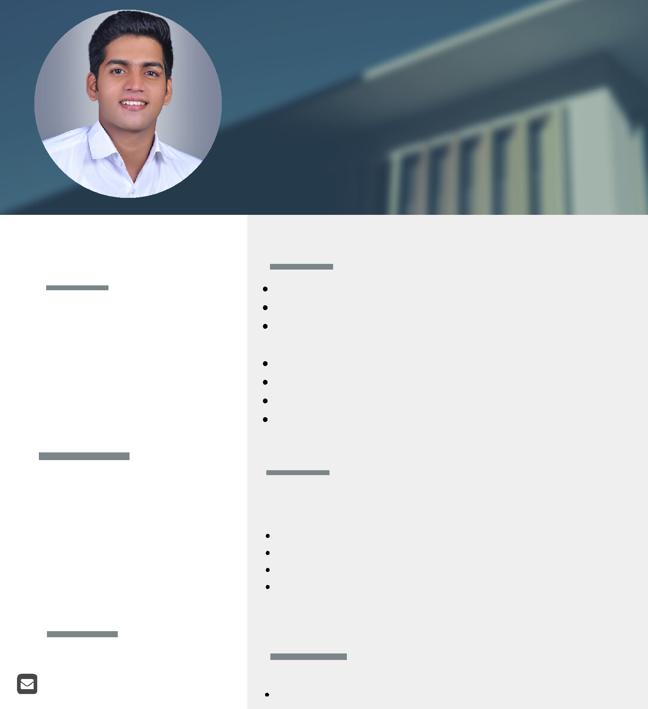

PERSONAL PROFILE

Extremely motivated to con stantly develop my skills and grow professionally. I am con fident in my ability to come up with interesting ideas

PERSONAL DATA

Date of Birth : Sepr / 7 / 1997

Nationality : Indian

Religion : Muslim

Driving license : 4 wheeler , LMV

Marital status : single

Language : English

CONTACT

Badusha-397363@gulfjobseeker.com

BADUSHA

SKILLS

MS office expert specially in Word and Excel

Expert in installation of various computer application Optical fution splicing ,cable laying outdoor and indoor

The ability to work under pressure and multi-task skilled in internet applications

optical fibre attenuation finding optical fibre cable laying supervisor

WORK EXPERIENCE

computer assistant
PUBLIC SCHOOL
JAN 2019 TO AUG 2019

Computer lab assistant

Computer teacher

MS office assistant

public relation officer

EDUCATION

Diploma in computer application (under govt) optical fibre technician (National certificate from BSNL)

DECLARATION

I do hereby declare that the particulars filled in above are correct and true to the best of my knowledge and belief.

