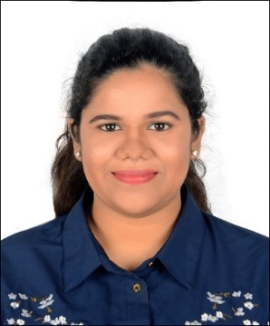
Nicole
Email ID: Nicole-397371@gulfjobseeker.com

Objective
To secure a challenging career that empowers my growth as a budding business professional. Thereby allowing me to bea positive resourceto a dynamic team, through my efficient management, decision-making and communication skills.

Skills &Competencies
- Communication Skills – The ability to convey information effectively and efficiently – verbal and written.
- Analytical Skills – Capability to analyzesituations and engage in fruitful negotiation– both internal and external
- Solution driven analysis – Capability to remain calm and stay solution focused in any given situation
- Team player – Maintain a positive work culture, and adhering to organizational guidelines.

COMPUTER EXPERTISE
- Proficient in MS Office – Advanced Excel, Word, PowerPoint & Outlook

Education
- BBA (Bachelor of Business Administration) - (Specializing in HR & Marketing) –2019(GayatriVidyaparishad, Visakhapatnam, India)

experience
Academic consultant(July2019 – January 2020)
- Demonstrating through PowerPoint presentations – Learning modules for higher education based on analysis of student need.
- Understand the customer’s profile to explain implication of ineffective learning methods.
- Handling objections and price negotiations to generate sales revenue.
- Engaging in healthy discussions, invite different approaches and ideas for strategies and processes.
- Identifying and analyzing the overused and outdated methods of learning that students are following and bringing awareness of this issue to their respective parents.
PLACEMENT PARK ( Visakhapatnam, India)
HR Recruitment - Internship (June – July 2019)
- Maintaining and Collaborating with hiring managers(internal and external) to ensure staffing goals were achieved.
- Screening resumes. Performing reference and background checks.
- Schedule and confirm interviews with candidates- In-Person and Telephonic.
- Administering appropriate company assessments
LG POLYMERS PVT LTD ( Visakhapatnam, India)
HR Recruitment - Internship (May - June 2018)
- Handling of employees personal files i.e. checking if their personal documents and other credentials where recorded properly.
- My internship was based on knowing the company’s recruitment and selection process and got the opportunity to witness the process with the HOD of HR & IR in the company.
- Gathering payroll data like working hours, leaves and bank accounts.
- Screening resumes and application forms. Post update and remove job ads from job boards, career pages and social networks.

Awards and Acknowledgements
- Active member of YOUNG INDIA (YI)
- Participated and won a prize in MWPS (Model world partnership summit) - AIESEC
- Participated in the NSE (National Stock Exchange) conference - Visakhapatnam.

PERSONALDETAILS :
Date of birth : May 9,1998
Nationality : Indian
Marital status : Single

