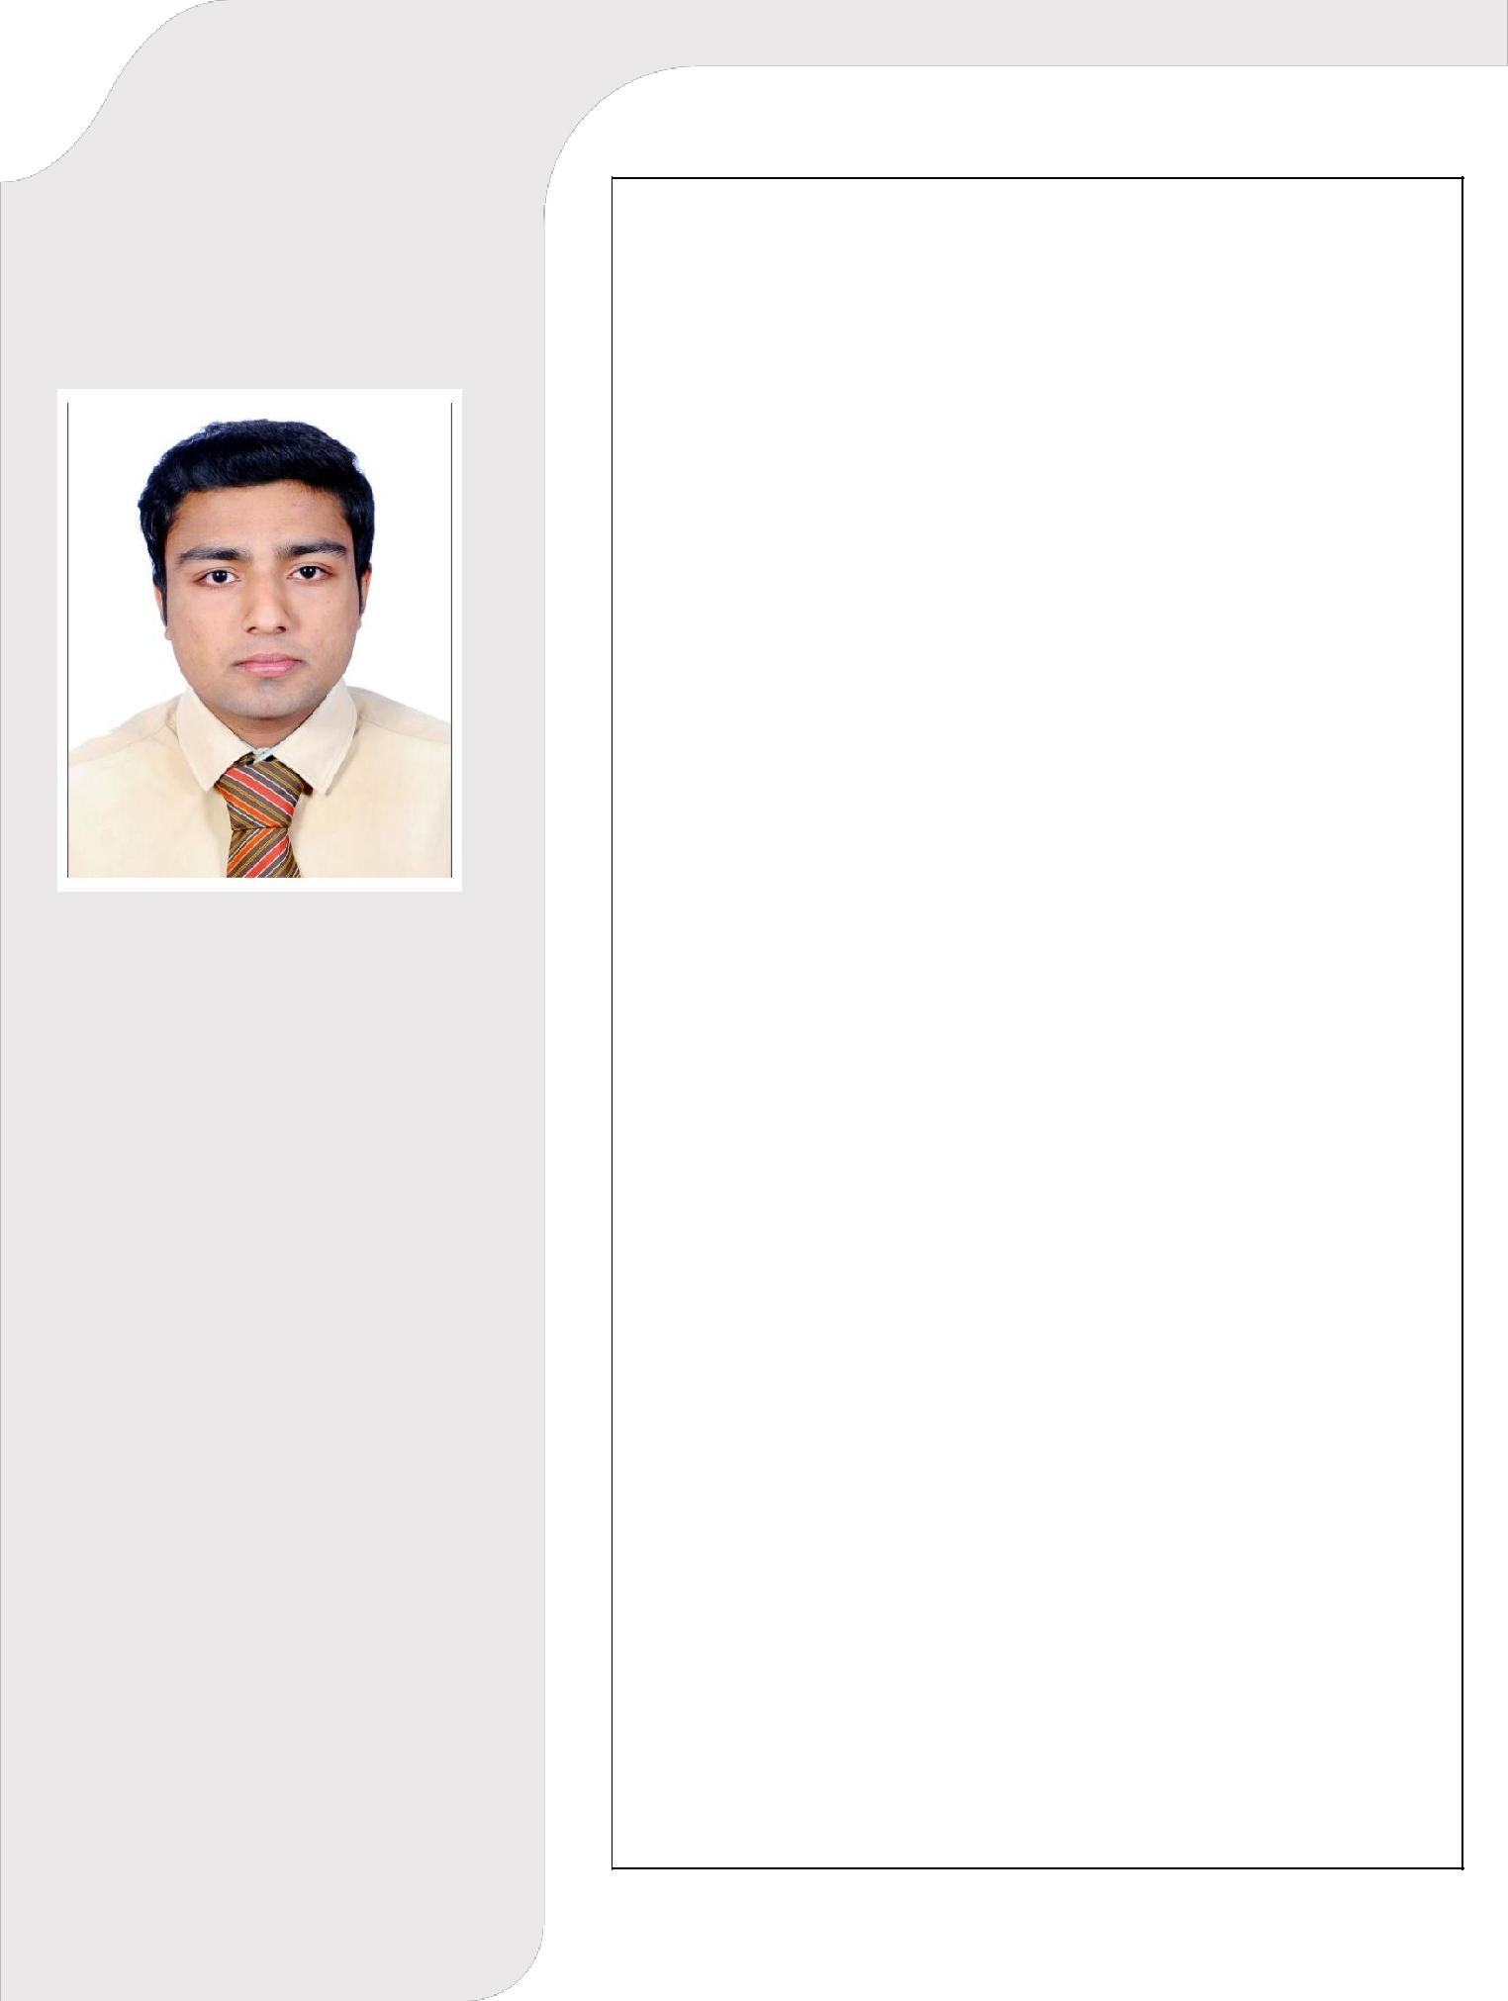
MINTU

Personal Info

Email:

Mintu-397390@gulfjobseeker.com

DOB:
1995-09-29

Visa Status:
Visit Visa - Till 12th May 2020

Believe in the principle that organization invests, empowers and provides ample growth opportunities to its employee. And employee in return contributes to the profit maximization, growth and success of the organization.

Education

- 2014: UG

- 2018: B Tech in Mechanical Engineering VAST, University Of Calicut, India

- 2018: QA/QC in Mechanical

- 2020: Revit MEP
✓

Professional Experience

- 1 and half year of experience as Engineer in Industrial Service Department

- Trainee at BOSCH & TUV Rhineland workshop

- Internship training at Cochin Shipyard

Rochem Separation Systems has been established with a view of making Plant installations, Piping, Electronic technology transfer with already proven firms on the globe and has combining 25 years of international engineering experience.

Roles & Responsibilities

- Implement site supervision, quality procedures and report submissions

- Prepare process datasheet for Equipment & Instrumentation

- Centrifugal and positive displacement pump services.

- P & ID evaluations

- Managing chemical logistics.

- Processes evaluation of Evaporators, RO and

MBR

- Conduct regular site visits and make maximum possible efforts to avoid contractor(s) claim on cost and/or delay

- Installation services

Skills

Site execution
Coordination

Problem solving

Good communication skills Strong attention to details

Certifications

QA/QC
Piping & Pipeline- ASME

NDT Methods
Welding Inspection- ASME

Revit MEP
Auto CAD

Languages

English
Hindi

Malayalam

Strengths

- Easy to get adapted in new conditions

- Team player and leadership skills

- Good knowledge in various types of process

- Self motivated, dedicated and hardworking

Project Involved

AYM Syntex, Mumbai

Declaration

I do hereby declare that all the information and details given above are true to the best of my knowledge.

Sharjah Mintu

