`
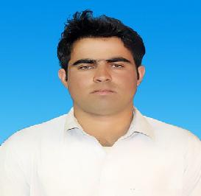

IMTIAZ

Email: imtiaz-397392@gulfjobseeker.com

Abu Dhabi-UAE

Objectives

As a Mining Engineer I wear my professional knowledge and skills for the progress and improvement of human welfare, organization and profession.

Education

BS Mining Engineering (2017)

Balochistan University of Information Technology, Engineering and Management Sciences

CGPA (2.94/4.0)

FSc Pre-Engineering (2013)

Karak Educator Model school & college karak KPK (753/1100)

Matric (2011)

Fauji Foundation model School Karak kpk Pakistan(764/1050)

Personal Information

Date of Birth : 1st Sep, 1996
Gender : Male

Religion : Muslim

Marital Status : Single

Nationality : Pakistan

Languages known : English, urdu, pashto

Experience

- Site Controlling Engineer (Jan 2018-fab2019) Project: -

Manganese Mine Killa Saifullah Balochistan Pakistan.

Responsibilities: -

Mine Designing Mine Mapping

Mine Cost Calculation

Giving Training to Workers about Separation of valuable material from waste and gangue material.

Pay salaries to workers.

Diesel Arrangement to heavy machinery. Preparation of daily reports.

- Management: -

Work & Study (April 2014-April 2015)

`

Preparing time table for Classes

Putting Students data in Campus Management System (CMS) Preparing Students Files

Putting Students Attendance in CMS

Hobbies

Social media & internet Surfing.

References

References available upon requests.

Declaration

I hereby certify that the above information is true and correct to the best of my knowledge and belief.

Imtiaz

