An adaptable and responsible professional seeking position in a challenging and healthy environment which will utilize the organizational and communication skills developed.To pursue a highly rewarding career, seeking a job in a challenging and healthy work environment where I can utilize my skills and knowledge efficiently for organizational growth.

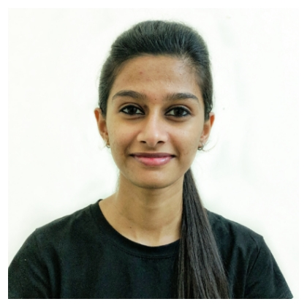
Nydhile
Sales Associate

Email
Nydhile-397396@gulfjobseeker.com

Experience

Sales Associate
(Bengaluru, India) 2018-2019
- Creating long term relationship with customers by providing outstanding service.
- Created seasonal clothing displays, including dressing and arranging mannequins.
- Inventory management.
- Styled Mannequin designs and managed the store front.
- Hnadle tasks of preparing and maintaining sales record on a daily basis.
- Participate in sales training and programs to enhance sales skills and technique
- Managed the cash register, including customer returns.
- Welcomed each customer to the store and offer help as needed.
- Managed displays year round, including seasonal displays.

Education

Computer science and engineering (70%) 2015-2019

Adichunchanagiri institute of technology, Chikkamagalur
Vishveshvaraya Technology University, Belgaum

Pre-University Collage(72%) 2013-2015

SDM PU Collage, Ujire

Skills

Professional  Customer service  Presentation skills  Time management  Client relationships | Web  Microsoft office  Internet  Java | Personal  Communication skills  Leadership  Active listening  Self-motivated  Problem solving  Quick learner

Achievements
- Earning an employee of the year award for making the most sales in a quarter.
Hobbies
Meeting people, self-research, browsing and cooking

Personal Details
Date of birth : 31/07/1996
Gender : Female
Nationality : Indian
Languages : English, Hindi and Kannada
Visa Status : Visit Visa

Declaration
I hereby declare that the above information’s are correct and complete to the best of my knowledge and belief.

Date:
Place: Signature

