CURRICULUM VITAE
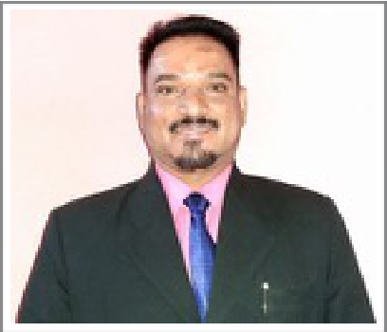

Name

: Mr. Pappachan

Gender

Marital status

: Male

: Married

Date of birth

Nationality

: 03/01/1973

: Indian

Email Address

: papachan-397398@gulfjobseeker.com

Language Known

: English, Hindi, Malayalam

Post Looking for

: Principal

Career Objective:

My position as a Principal, involves over all incharge-ship, curriculum development, instructor assessment and providing results for CBSE regulations. I have planned, designed and implemented various academic and non academic incentive programs for student’s enrichment and teachers and other agents of the institution which have resulted in excellence.

I am blessed with the leadership qualities like “walks the talk”, enriched with good character and trustworthiness, enthusiastic about the work, full of passion and dedication, a source of inspiration, good motivator, always the part of the team working towards the goal, confident. orderly and purposeful, tolerant in ambiguity, focused, committed to excellence. Makes the institution and oneself proud.

Academic Qualification:

Qualification | Institution | University/ Board | Place | Year
SSLC | St. Antony’s High School, Mala | Kerala Board | Kerala | 1990
ITC (Electrical Engineering) | Regional Technical Training Institute, Chalakudy | Kerala | Kerala | 1992-1994
Higher Secondary School | St. Thomas Sen. Sec. School, Jabalpur | MP Board | MP | 1995

Higher Qualification | Institution | University/ Board | Place | Year
BA (Eco., Phil.) | St. Francis De Sales College | Nagpur University Nagpur | MH | 1998 -2001
Diploma in Philosophy | St. Charles’ Seminary Nagpur | St. Thomas Aquinas University Rome | MH | 1998 -2001
Diploma in Theology | St. Charles’ Seminary Nagpur | St. Thomas Aquinas University Rome | MH | 2002 -2006
MA Politics | St. Aloysius College, Jabalpur | Rani Durgavati University Jabalpur | MP | 2008 -2009
MA English | Jiwaji University Gwalior | Jiwaji University Gwalior | MP | 2014 -2015
B Ed (English, Eco.) | Devi Ahilya University Indore | Devi Ahilya University Indore | MP | 2011 -2012

Work Experience

Designation | Office | Duration | Institution
 |  |  | St. Aloysius Senior Secondary School Jabalpur (Mission School) in MP.
Principal | Principal | 2006 -2018 | Modern School Bharatpur,
 |  |  | Karan International School Morena.
 |  |  | RPS Senior Secondary School, Sirsa, Hariyana.
Principal | Principal | 2018 -2020 | Currently working

CURRICULUM VITAE

Achievements:

- Awards :Awarded certificates in the All India level ICESSchool Leaders.

- Trainings : Attended National level leadership trainings.

- Leadership positions: I have led and managed various teams, classes and groups in school, college levels and social group called “Bhalajanasakyam” Children’s group of Malayala Manorama News Paper.

- Sport: Many awards in sports faculties in school level, college level, district level and university level

- Certificates: I have achieved many certificates in various levels.

- Special responsibilities: President of Church Family Units, Join Secretary of Coconut Producing Farmers Society, The President of Paddy Producing Famers Society.
- Membership of Associations: Member of “CongressParty, “Sevadel”,

- Membership of sporting teams:School level Football Team Captain, Cricket Team. College level Badminton Team

- Achievements in the Arts, Drama: I was awarded various certificates in Drawing and Acting on stage shows. Acted in Professional Drama troop.

Skills:

- Languages: I have a very good knowledge in English, Hindi and Malayalam

- Technology Skills: I own a high level skill in Electrical Engineering, Plumbing, and Computer Hardware

- Basic computer use: I am blessed with basic computer knowledge.

- Other Skills:Administrative skills, English Language and Phonetics trainer, Personality Development

Trainer, Motivational Speaker and Excellent orator, Good councillor, Good Writer

Advanced Computer Skills:

- Video editing: I have learned Media communication. Know well the video shooting and editing.

- Microsoft Excel: I know to work in the excel and publisher.

- Solving hardware problems: I know to solve some of the hardware problems.

Other Technology Skills:

- Good Electrician

- Good in Short film or documentary making

Hobbies:

Reading, drawing, working in computer, gardening

Declaration:

I hereby declare that the information furnished above is true to the best of my knowledge and belief.

Place: From Kerala, Residing in currently in Morena, MP yours truly,

Mr. Pappachan

