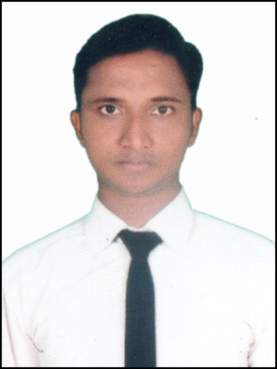
CURRICULUM VITAE

ZAKIR
E-mail ID No: zakir-397405@gulfjobseeker.com

Application for Steward

Objective :
- To work with an organization where into prove my abilities for best utilization of the organization.
- To establish myself as successful professional by optimum utilization of my potential & skill, seeking challenging and conductive environment to exhibits my learning, confidence, and to make the best use of available resources. As a result there will be simultaneously growth and expansion of the organization and my personal career.
Strength:
- Self Confidence.
- Ability to adopt and adjust in different Environment.
- Ability to work for long Hours.
- Ability to extra responsibilities and Hard working.
Weakness:
- Overthink about the work untilsits done.
- Always try to add Perfection while finishing my Work.
Experience:
- I completed my Industrial Training(IT) from Ramoji film city TARA Hotel,Hyderabad
- Duration:
    - 6 months
- I Completed my Job Training(JT) From VITS Hotel,Bhubaneswar
- Duration:
    - 6 months
- I had Worked in Leisure-inn Hotel as a STEWARD at GURGAON,Delhi
- Duration:
- 6 months
- I had Worked as a STEWARD
- Duration:
- 1 Year 5 months
Responsibilities:
- Greets guest and present them with the menu.
- Inform guests about the special items for the day and menu changes if any.
- Suggest food and beverages to the guest and also try to upsell.
- Obtaining revenues, issuing receipts, accepting payments.
- Observes guests and ensure their satisfication with the food & Service.
- Performing basic cleaning tasks as needed or directed by Captain.
Educational Qualification:

Passed | Board/University | School/College | Year of passing | Percentage
B.sc in Hotel Management | Ravenshaw University | Ravenshaw University | 2016 | 65%
PGDCA | Odisha Govt. Undertaking | Omega Computer | 2016 | Grade (A)
+2 Science | C.H.S.E. , Odisha | Elisa Jr. College | 2012 | 51%
10th | C.B.S.E,New Delhi | Holy Angel Convent School | 2010 | 76%

Personal Information:
- ate of Birth : 10.04.1994
- Sex : Male
- Nationality : Indian
- Religion : Islam
- Language Known : English,Hindi,Oriya
- Marital Status : Married
- Hobbies : Listening Music, Watching News, Playing Cricket

Declaration :
I do hereby declare that all the above information are true to the best of my knowledge and belief.

ShaikhZakir
Place: Cuttack Signature of Candidate
Date:

