REHAN
Email: rehan-397421@gulfjobseeker.com

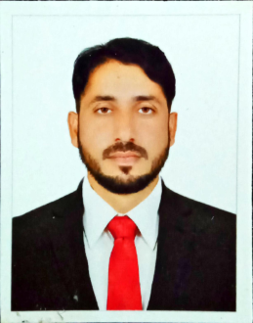
Career Objective:

To serve in a organization with devotion determination, dedicated and hard work; satisfying superiors by increasing coustumer satisfaction through quality service.
B.A/ Mass communication
Allama Iqbal Open University.
F.A
Govt. Degree College Shujabad, Multan.

SSC (Metric with Science)

Allama Iqbal Public School Shujabad, Multan, Board of Intermediate & Secondary Education, Multan.
Computer Networking Technician

Punjab Board of Technical Education Lahore.

Professional Experience:

- Shift Incharge in a Hotel.
- Stock in charge in Bahum associate.
- Work as voluntary with ILM NGO.
- Admin officer in SC Collage.
- Teaching in Punjab Public High schooI'ml.
- Attend workshops under the different NGO.
- During job times & uses all office instruments.
- Immediately available for job.

Personal Details:

Nationality : Pakistan
Date of birth : 10/02/1989
Material Status : Unmarried
Religion : Islam
Language : English,Urdu

IT Diploma:

- Microsoft office
- INPAGE Urdu 2.4
Use of Printer & Scanner

Extra Activities:

- Reading books.
- Finding new software’s through internet.
- Playing different games like as Cricket.

Declaration:

I hereby declare that above-mentioned information is correct up to my knowledge and I bear the responsibility for the corrections of tha above-mentioned particulars.

Rehan

